

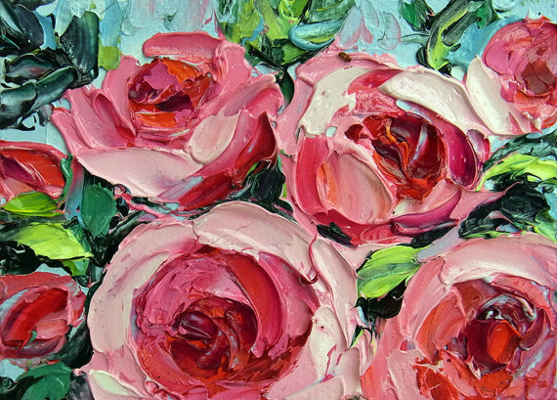 UAL Awarding Body

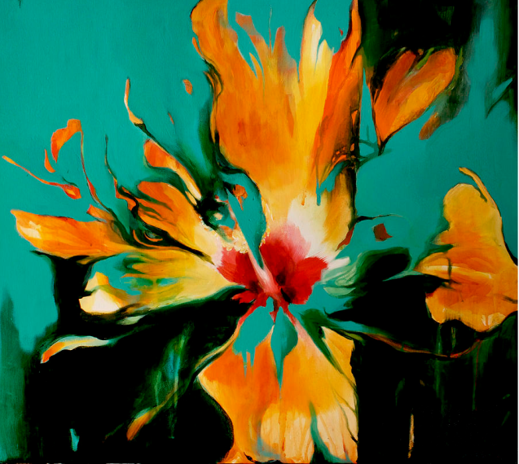

|  |  |
| --- | --- |
| **Course Title** | **Level 1 Diploma in Art, Design & Media** |
| **Assignment Title** | **Summer Assignment:** Nature Close Up |
| **Staff** | Allyson Beckford |
| **Units Covered** | **Unit 1**: Introduction to materials, processes  & skills in art and design media |
| **Date Set: June, 2024** | **Due Date**:  *Please note: You* ***MUST*** *bring this completed assignment into college when you come to enrol in September, this date will be sent to you during the summer.* |

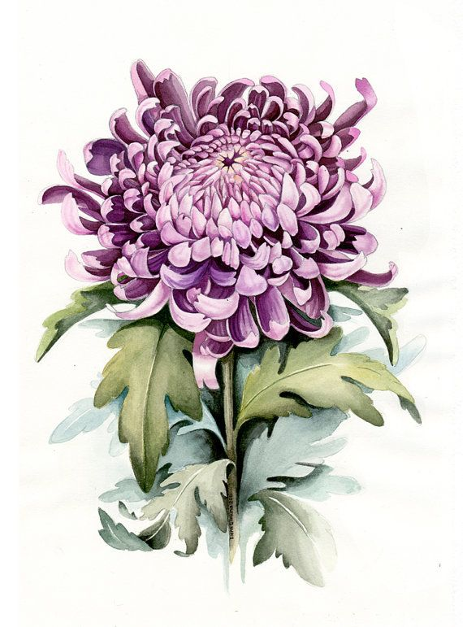

# Introduction

The purpose of this summer project is for you to begin to look at the world around you and record what you see using a range of different media and digital photography. Avoid going back to the drawing and paint techniques that you were comfortable with at school, instead, look to explore how others have tackled the theme of this project and aim to have a go at using their techniques. You will need to be varying your choice of media as you progress with each drawing you produce.

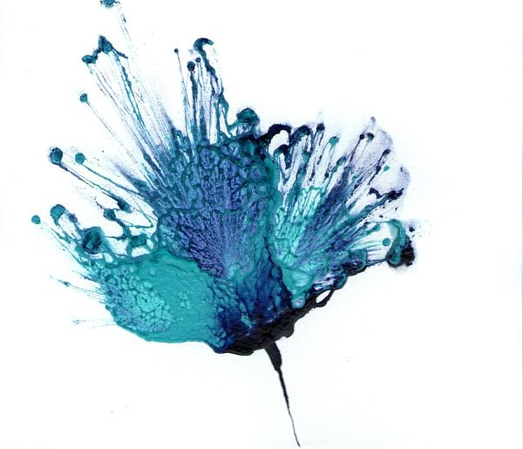**Part 1**

* **Drawings**: I need you to begin by producing some drawings and paintings of objects from nature, but observed close up, selecting various colours and shapes that you find interesting to you. You will need to select a variety of interesting natural forms to work from. *Don’t* draw from photographs; you *must* have your objects in front of you as you draw.
* Think about how you draw. Ask yourself what are the most interesting or unusual angles you can use? Don’t draw in the middle of a page and leave the remaining space blank. Aim to draw large to fill the space available and make everything look as interesting as you can.
* If you are stuck and don’t know what to draw perhaps get on-line and look at some examples of other illustrators and artists work to inspire you. Many illustrators use plants, flowers, insects and animals within their work so you should be able to find someone whose work could then inspire your own drawings.
* 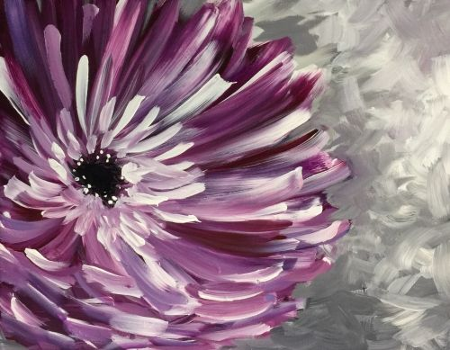As you develop your drawings, aim to change the media you use with each one. Examples could be biro, a rich coffee wash, charcoal rubbed over a page and then draw into this with a rubber, liquid ink, a range of graphite pencils, marker pens….the options are endless. Just be imaginative and varied in your approach.

**Aim to develop a MINIMUM OF 6 different studies, changing your subject and choice of media in each one of your drawings**

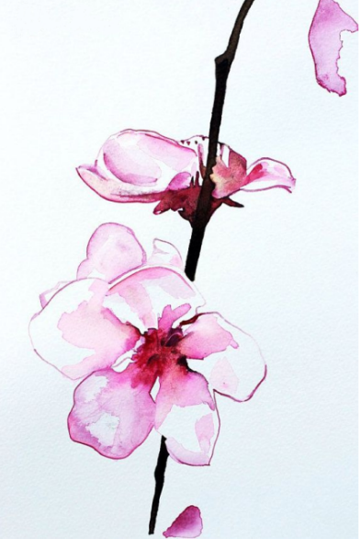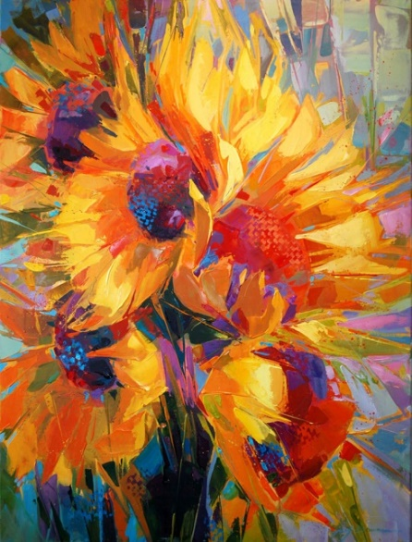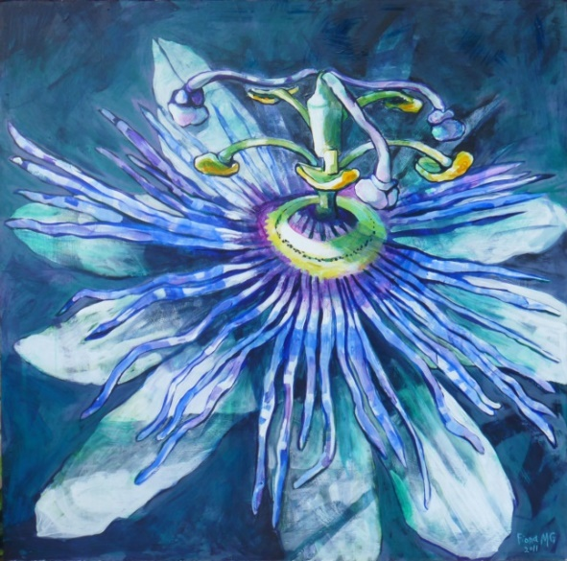

**Part 2**

**Photography**: For this section of the project, you will need to have access to a digital camera / camera phone of your choice. Before you begin, it’s worth going back to the camera menu to explore all the options available, such as sweep panoramic, lighting settings, macro for close up shots, sepia…etc. and aim to explore these options as you develop your photos. It will also be worth experimenting with photo manipulation apps and/or free downloads such as PicMonkey.com

* As you go looking for examples of natural forms such as pets, plants and flowers, aim for interesting arrangements where they are captured within their natural environment, such as in fields, formal gardens, natural meadows, glass house etc. When off on location, be sure to take someone with you to assist you in your work. If you are heading off on holiday or visiting a new location, this will be a great opportunity to photograph new plants and flowers.
* You can work on any size of paper you wish up to A3 and any paper type that you can find; in fact, the more varied the better. You will eventually be mounting your photos into your first A3 sketchbook.

**Aim to gather and print out a MINIMUM OF 10 different close-up photographs, targeting your strongest images. This work will form part of your first project assessment so please take your time and ensure that you produce this work to the best of your ability.**

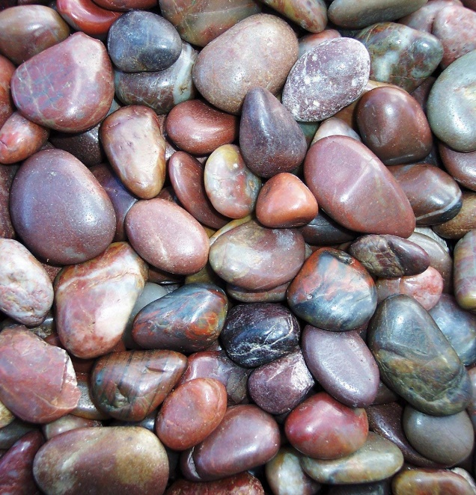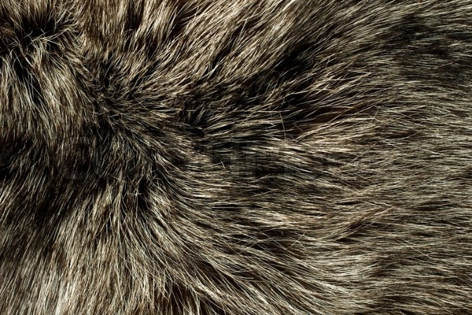

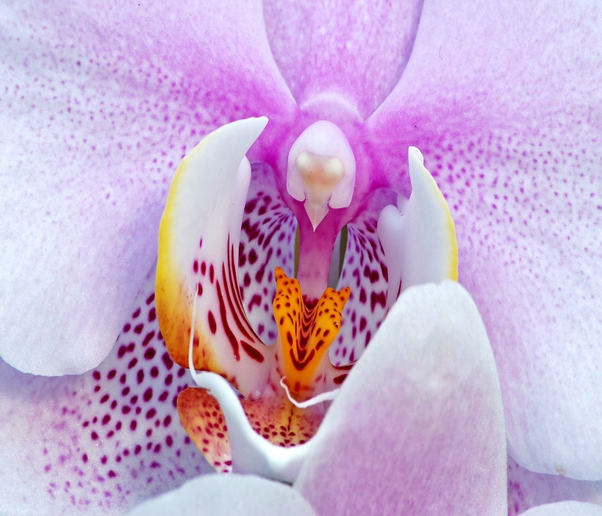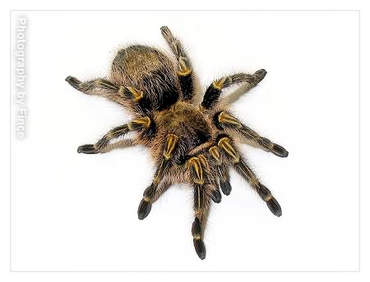

If you have any questions regarding this work or have any questions about your course please do not hesitate to email me via

allyson.beckford@ieg.ac.uk

**Equipment List**

Level 1 Art & Design

In preparation for your start on the level 1 art course, you will need to be gathering together the following equipment to ensure you are ready to go in September.

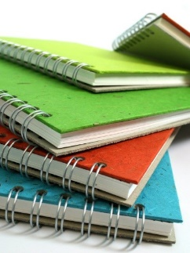 **Sketchbook**

You will need an A3 sketchbook for your main coursework. Avoid buying a cheap sketchbook as the paper used is of such poor quality. Ideally, choose from the ‘Pink Pig’ range.

**Glue Sticks**

You will be using *a lot* of glue sticks over the year, so if you have the opportunity, aim to buy in bulk. We have tried numerous brands, but it’s ‘Pritt’ that always gets the job done.

**Graphite Pencils**

You will need to source a set of 12 graphite pencils, as the broad range of H to 9B pencils will be crucial in developing your drawing skills over the year.

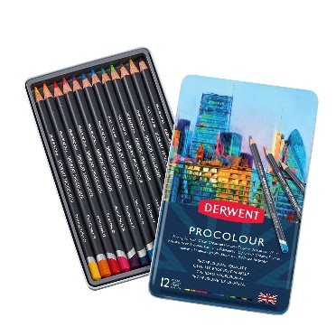 **Colour Pencils**

As with the sketchbook, it is a case of selecting a good quality brand. Derwent have a good range, from studio pencils to water-soluble pencils, all have proved very reliable.

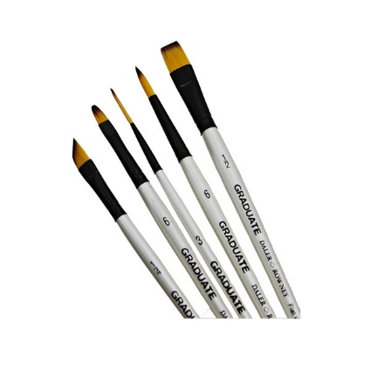 **Brushes**

There are two varieties, the soft artist brush and the firmer bristled brushes. It’s the soft ones you will need to have. These can be bought as a set from outlets like ‘*The Works*’ or selected individually from ‘*Hobby Craft’*. If you are buying individual brushes, target the cheaper but reliable white *graduate* set of brushes.

**General Equipment**

You will probably have a lot of this left over from school.

Can you ensure you have the following items ready to go:

***Metal Ruler, Craft Knife with a snap-off blade, Scissors, Rubber, Writing pen***

***and a decent sized bag to store all of the above equipment***