**Equipment List**

UAL Level 2 Art & Design 2024/5

In preparation for your start on the level 2 Art and Design course, you will need to be gathering together the following equipment to ensure you are ready to go in September.

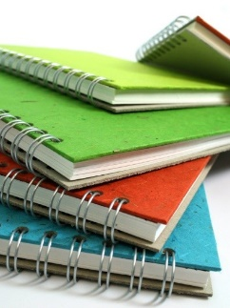

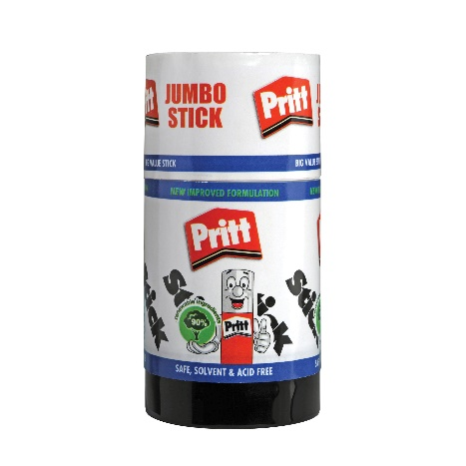 **Sketchbook**

You will need an ***A3 sketchbook*** for your main coursework. Avoid buying a cheap sketchbook as the paper used is of such poor quality. Ideally, choose from the ‘Pink Pig’ range.

**Glue Sticks**

You will be using *a lot* of glue sticks over the year, so if you have the opportunity, aim to buy in bulk. We have tried numerous brands, but it’s ‘Pritt’ that always gets the job done.

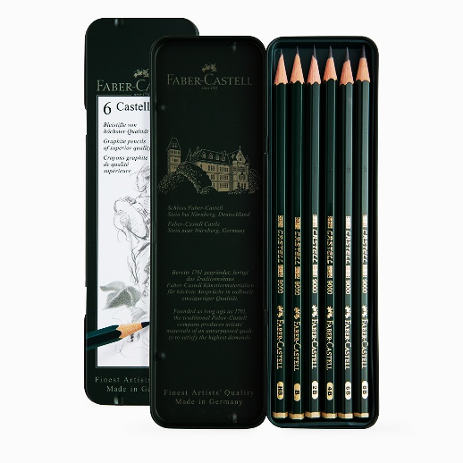 **Graphite Pencils**

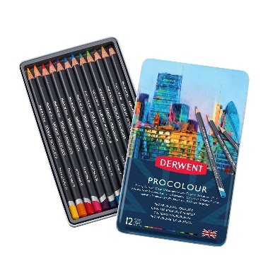You will need to source a set of 6 graphite pencils, as the broad range from HB to 8B pencils will be crucial in developing your drawing skills.

**Colour Pencils**

As with the sketchbook, it is a case of selecting a good quality brand. Derwent have a good range, from studio pencils to water-soluble pencils, all have proved very reliable.

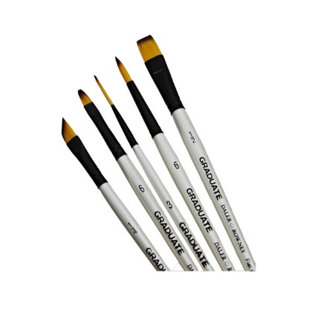 **Brushes**

There are two varieties, the soft artist brush and the firmer bristled brushes. It’s the soft ones you will need to have. These can be bought as a set from outlets like ‘*The Works*’ or selected individually from ‘*Hobby Craft’*. If you are buying individual brushes, target the cheaper but strangely very good quality white ‘*graduate’* set of brushes.

**General Equipment**

You will probably have a lot of this left over from school.

Can you ensure you have the following items ready to go:

***Metal ruler, craft knife with a snap-off blade, scissors, rubber, writing pen and a decent sized bag to store all of the above equipment. Having your own tablet or Kindle to use will prove to be handy, but not essential.***