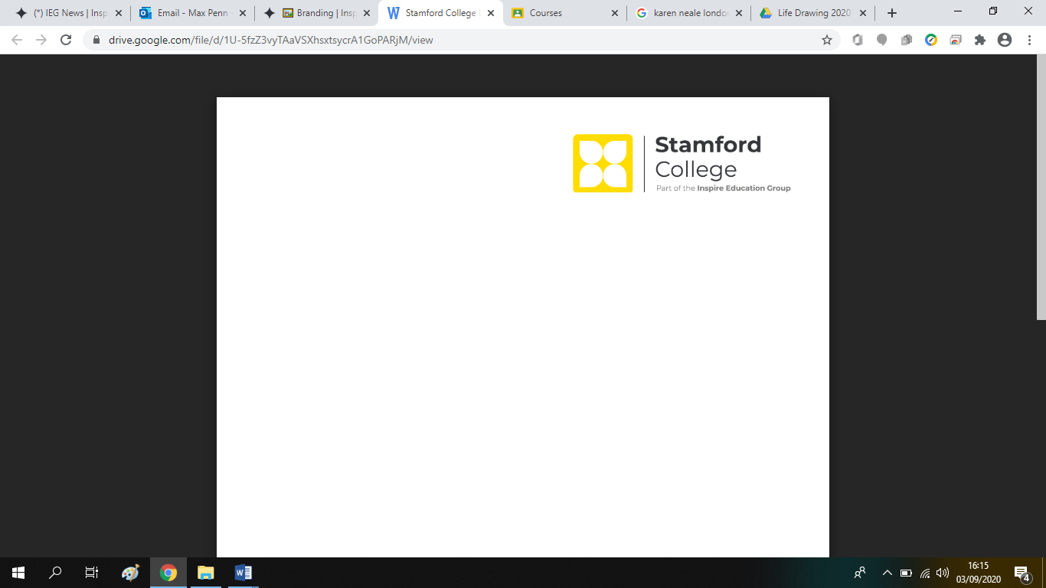

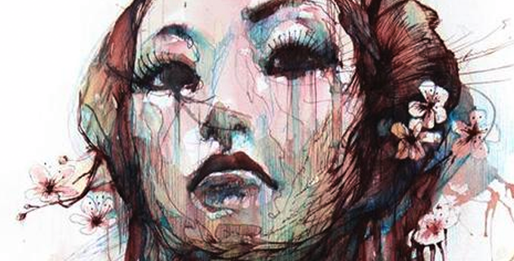 UAL Awarding Body

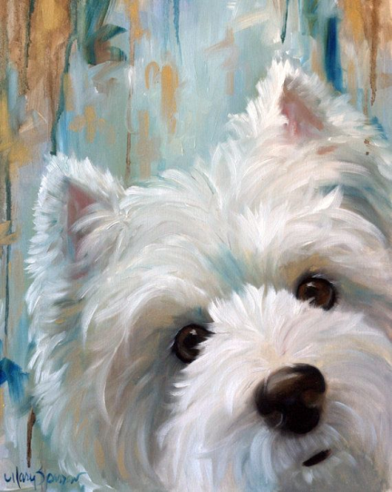

|  |  |
| --- | --- |
| **Course Title** | **Level 2 Diploma Art & Design** |
| **Assignment Title** | **Summer Assignment**: **Faces** |
| **Staff** | Max Penn |
| **Units Covered** | **Unit 1**: Introduction to Visual Language in Art and Design |
| **Date Set: July 2024** | **Due Date**:  *Please note:* ***YOU MUST*** *drop off this completed assignment*  *When you come in to enrol at Stamford College.* |

# Introduction

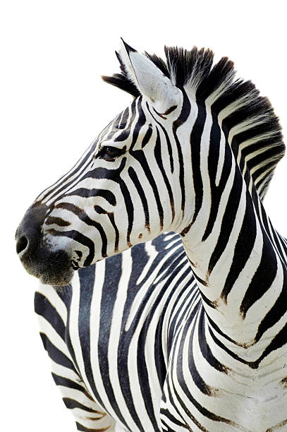The purpose of this summer project is for you to begin to look at the living world around you and record what you see using and combining a range of different media as well as using digital photography. Avoid going back to the drawing and paint techniques that you were comfortable with at school, instead, look to explore new techniques and begin to mix two or more media together with each drawing you produce. As you begin the drawing and photographing of your subjects, you will need to concentrate on ‘***the formal elements***’

What does ‘***Formal Elements’*** mean?

As you get ready to draw or line up your camera ready to take that perfect photo, stop, observe and consider the following things before you begin - ***line, tone*** *(light and dark)****, shapes, surfaces, textures, patterns*** and the ***space around your subject***. How could your drawing styles, choice of media and camera settings best capture some of these elements?

**Part 1 - Drawing Tasks**

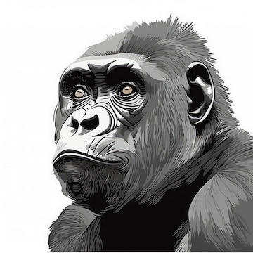During your summer vacation, I need you to produce a set of 6 drawings on the theme of ***faces***, selecting various people, pets or wild animals that you find interesting, for you to then draw their faces. You will need to select animals and people you can easily get access to and who won’t move around too much whilst you are drawing them. ***Don’t draw from photographs***; the animals and people *must* be in front of you as you draw.

* Think about how you compose your page, what are the most interesting or unusual angles? Consider grouping animals or people together (crowds), study their expression, eyes and head posture. Think about the scale of your work – it can be any size up to A3, so try different sizes. Don’t draw in the middle of a page and leave the remaining space blank. Aim to fill the space available and make everything look as interesting as you can. The more unusual your technique and media application, the better
* If you are stuck and don’t know what to draw perhaps get on-line and look at some examples of other illustrators and artists work to inspire you (Pinterest). Most will have used people and animals as references for their work so you should be able to find someone whose technique could then inspire your own drawings. Go to YouTube, and look at the short tutorials delivered by ‘Proko’ to help improve your plotting technique.
* As you develop your drawings, aim to *mix two different media*, from the traditional to the more unusual. Extensive examples can be found on Pinterest, but it could be media such as biro and watercolour, charcoal over a page and then draw into this with a rubber, liquid ink applied with a sharpened edge, a range of graphite pencils and writing pens, marker pens then brushed over with a damp brush…. the options are endless. Just be imaginative and varied in your approach.

**Aim to develop a *MINIMUM OF 6* different drawings, changing your subject and choice of media in each one of your drawings**

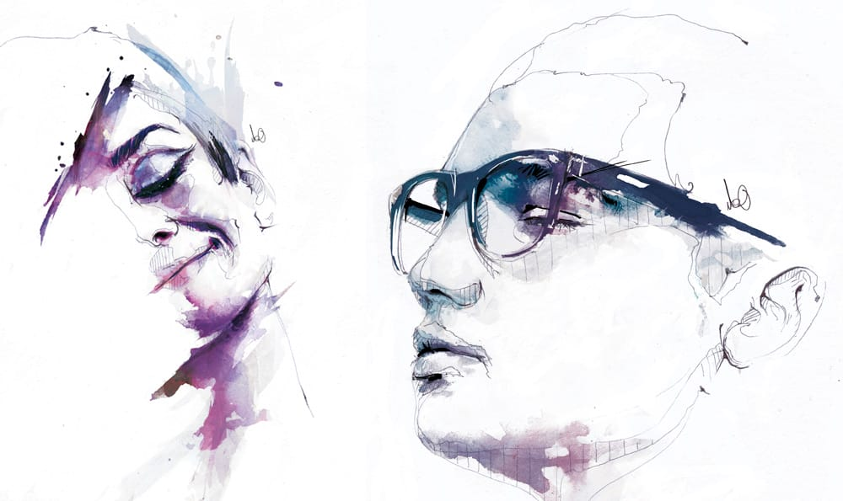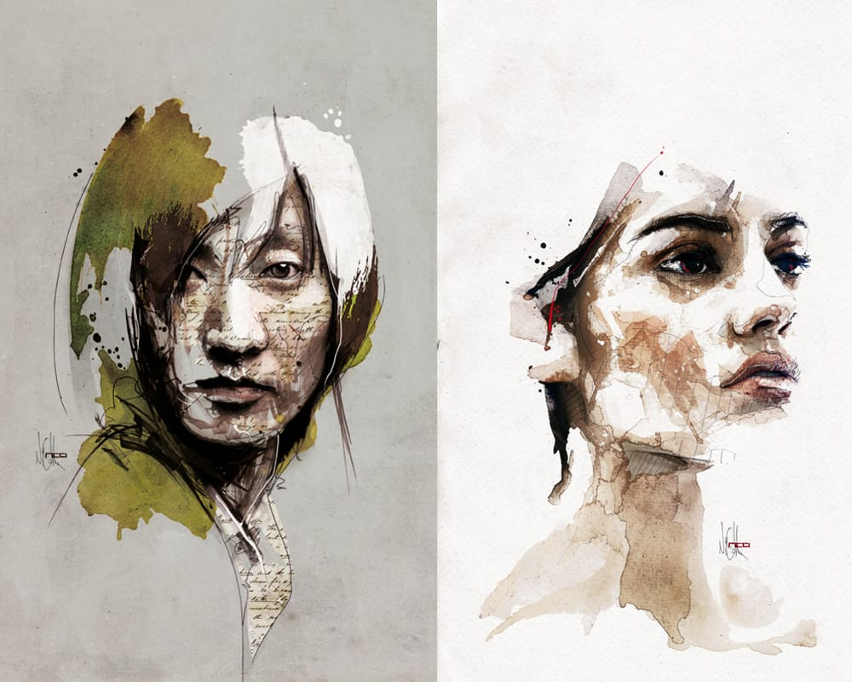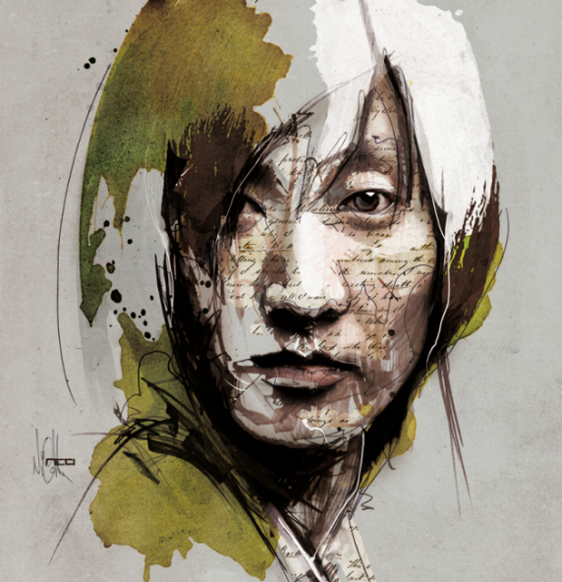

**Part 2 – Photos**

* For this second and final section of the project, you will need to have access to a digital camera of your choice. Before you begin, it’s worth going back to the camera settings to explore all the options available, such as sweep panoramic, lighting settings, sepia, 70’s, black and white…etc. and aim to explore these options as you develop your photos. It will also be worth experimenting with creative photo manipulation apps.
* As you go looking for examples of people and animal faces, aim for interesting arrangements where they can be captured within their daily environment, such as farms, zoos, being walked, sporting events (Burghley), music festivals, relaxing on holiday…etc. When taking photos on location, be sure to take someone with you to assist you in your work. If you are heading off on holiday or to a new location, this will be a great opportunity to photograph new cultures. I would recommend you take between 80 – 100 photos to then select the 10 best. ***No selfies, or snapchat filters***
* Your work can be any size you wish up to A3 and any paper type that you can find; in fact, the more varied the better. You will eventually be mounting your photos into your first A3 sketchbook during your first week at college.

**Aim to develop, print and mount your *10 STRONGEST PHOTOGRAPHS*.**

If you do not have a printer at home, just compile your 10 images on a word document or as jpeg’s and send them in to me before the start of term. Email via: [max.penn@ieg.ac.uk](mailto:max.penn@ieg.ac.uk)

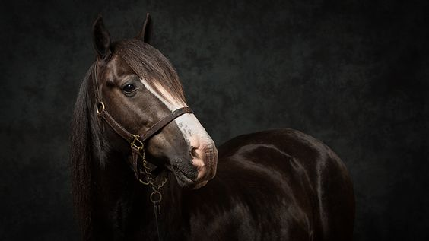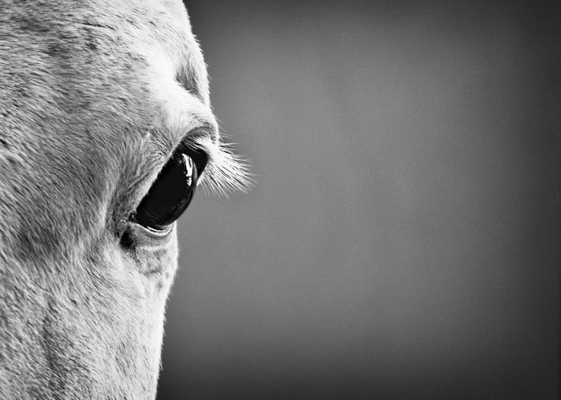

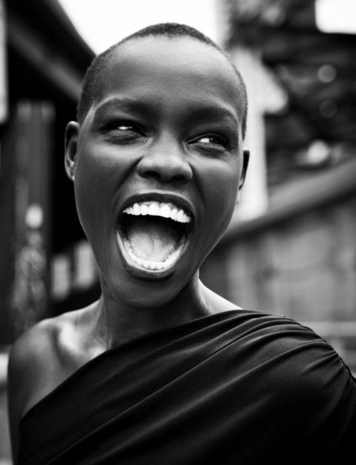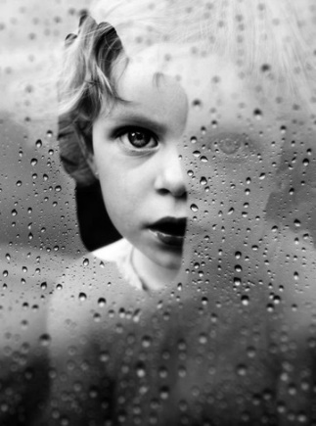

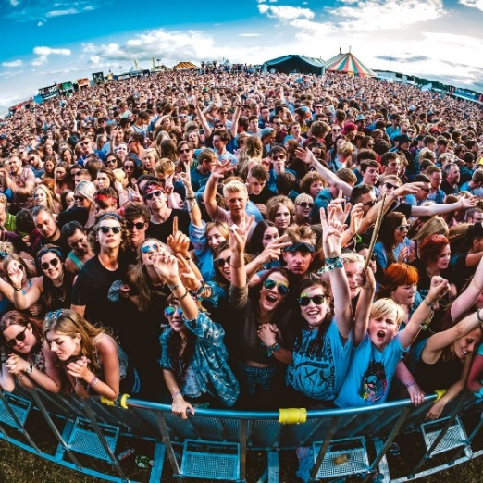

If you have any questions regarding this work or have any questions about your course please do not hesitate to email myself or our department manager via [rachael.cooper@ieg.ac.uk](mailto:rachael.cooper@ieg.ac.uk)

**Equipment List**

UAL Level 2 Art & Design 2024/5

In preparation for your start on the level 2 Art and Design course, you will need to be gathering together the following equipment to ensure you are ready to go in September.

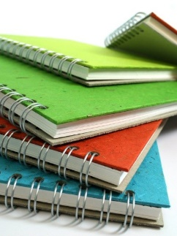

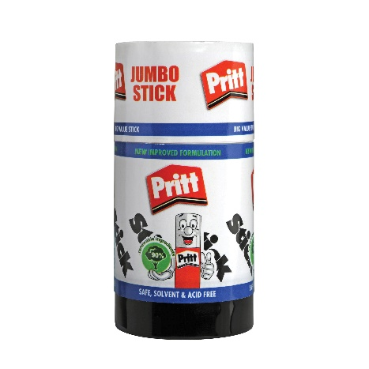 **Sketchbook**

You will need an ***A3 sketchbook*** for your main coursework. Avoid buying a cheap sketchbook as the paper used is of such poor quality. Ideally, choose from the ‘Pink Pig’ range.

**Glue Sticks**

You will be using *a lot* of glue sticks over the year, so if you have the opportunity, aim to buy in bulk. We have tried numerous brands, but it’s ‘Pritt’ that always gets the job done.

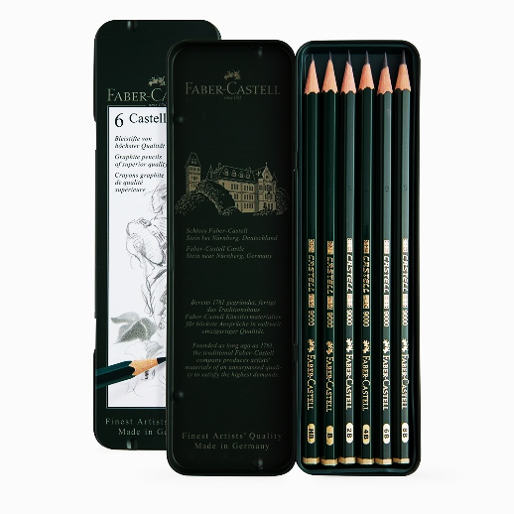 **Graphite Pencils**

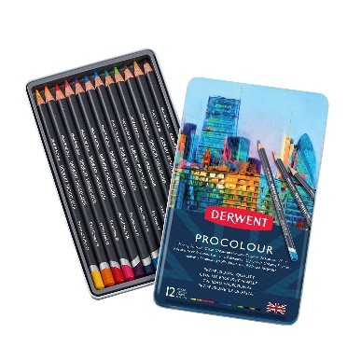You will need to source a set of 6 graphite pencils, as the broad range from HB to 8B pencils will be crucial in developing your drawing skills.

**Colour Pencils**

As with the sketchbook, it is a case of selecting a good quality brand. Derwent have a good range, from studio pencils to water-soluble pencils, all have proved very reliable.

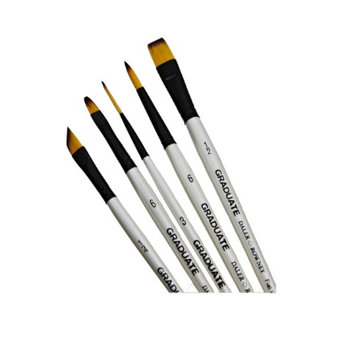 **Brushes**

There are two varieties, the soft artist brush and the firmer bristled brushes. It’s the soft ones you will need to have. These can be bought as a set from outlets like ‘*The Works*’ or selected individually from ‘*Hobby Craft’*. If you are buying individual brushes, target the cheaper but strangely very good quality white ‘*graduate’* set of brushes.

**General Equipment**

You will probably have a lot of this left over from school.

Can you ensure you have the following items ready to go:

***Metal Ruler, Craft Knife with a snap-off blade, Scissors, Rubber, Writing pen and a decent sized bag to store all of the above equipment. Having your own tablet or Kindle to use will prove to be handy, but not essential.***