

**LEVEL 1 & 2**

**NVQ Diploma in Beauty Therapy**

**G20 & EKU Workbook 2024-2025**

**IMPORTANT: Please complete this assignment to the best of your ability, answering each of the questions in full. This task will be marked and your overall grade will go towards the initial assessment process and will help us to determine which level of course will be most suitable for you.**

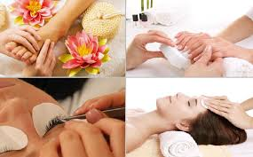

**NAME:**

**GROUP:**

**Issue Date: Monday 1st July 2024**

**Submission Date: Tuesday 3rd September 2024**

**INTRODUCTION**

As part of the beauty therapy level 1 or 2 qualification it is essential that as a therapist you have knowledge and understanding of certain elements which will cover aspects of each subject area.

With this knowledge you will be able to apply this to your practical element and gain the confidence and professionalism required for when you work in the industry.

The outcome of this workbook is to fully complete all the tasks and this will assist with your learning journey. This **booklet will be required as evidence** **(G20)** and will be filed with your core units of your portfolio.

**Please ensure where possible, you complete all tasks digitally or if you do not have access to a computer write in the same coloured pen (i.e. black or blue),** follow the instructions and proof read your work, consider your spelling, grammar & punctuation throughout.

Happy learning

C:\temp\Temporary Internet Files\Content.IE5\5FSMULNB\MC900437990[1].wmf

**OUTCOMES**

For every outcome you must complete each task with the relevant questions fully to meet the criteria.

Remember to proof read your work, checking for spelling, grammar and punctuation throughout, also ensuring you use the correct terminology.

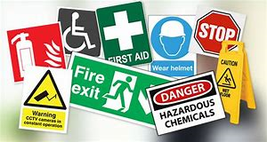

* **Task 1** – Legal responsibilities
* **Task 2** – Working with minors
* **Task 3** – Equality & Diversity
* **Task 4** – Personal Presentation
* **Task 5** – Client Data
* **Task 6** – Blended Learning Consortium



# Glossary of assignment words:

**Explain -** give reasons for, illustrate the meaning of, account for (in terms of a theory or rationale), make clear and intelligible

**Note:** **Answers must be detailed and not bullet points**

**TASK 1 - LEGAL RESPONSIBILITIES –**

1. Research each of the following work acts & complete the attached table, ensuring that you write a paragraph about each one, please put into your own words and make it relevant to the beauty industry, by providing an example of how this act is used within a salon. (Use this link to guide you with your research)

<https://www.fsb.org.uk/resources-page/health-and-safety-hair-and-beauty-salon.html>

<https://www.slideshare.net/slideshow/health-and-safety-legislation-39142564/39142564?from_search=0>

<https://www.slideshare.net/slideshow/core-hazards-and-risks/39142716#1>

|  |  |
| --- | --- |
| **WORK ACT** | **DESCRIPTION** |
| **Health & safety at Work Act** | *Definition:*  *Example:* |
| **Manual handling** | *Definition:*  *Example:* |
| **PPE** | *Definition:*  *Example:* |
| **COSHH** | *Definition:*  *Example:* |
| **Electricity at Work Act** | *Definition:*  *Example:* |
| **Portable Appliance Testing** | *Definition:*  *Example:* |
| **First Aid** | *Definition:*  *Example:* |
| **RIDDOR** | *Definition:*  *Example:* |
| **Fire Precaution Act** | *Definition:*  *Example:* |
| **Liability Insurance** | *Definition:*  *Example:* |
| **Risk Assessment** | *Definition:*  *Example:* |
| **Data Protection (GDPR)** | *Definition:*  *Example:* |

**B) Explain what a ‘hazard’ is? - Provide 2 examples of hazards within a beauty salon?**

**Explain a hazard: -**

**Example 1.**

**Example 2.**

**C) Explain what a risk is? - Provide 2 examples of risks within a beauty salon?**

**Explain a risk:-**

**Example 1.**

**Example 2.**

**D) State at least 2 roles of the Health & Safety Officer at Stamford College?**

<https://nationalcareers.service.gov.uk/job-profiles/health-and-safety-adviser#:~:text=advise%20and%20train%20staff%20on,record%20accidents%20in%20the%20workplace>

**1.**

**2.**

**E) List the six main roles & responsibilities of a ‘First Aider’ within the Beauty department;**

[***https://www.sja.org.uk/get-advice/i-need-to-know/the-role-of-the-first-aider/***](https://www.sja.org.uk/get-advice/i-need-to-know/the-role-of-the-first-aider/)

**1.**

**2.**

**3**

**4**

**5**

**6.**

**F) If an accident were to occur within the Clinics who should this be reported to (include the names of the beauty lecturer’s/technicians)**

**1.**

**2.**

**TASK 2 - WORKING WITH MINORS**

**Q2**. **Explain why minors should not be given a treatment without informed and/or signed parental or guardian consent.**

**Why is it important that a parent/guardian should be present at the consultation/treatment?**

**Answer:**

**Q1**. **State the age at which an individual is classed as a minor, in beauty therapy in the UK?**  (Use the QR code below to guide you with the answer)

**Answer:**

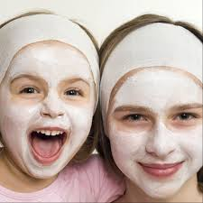

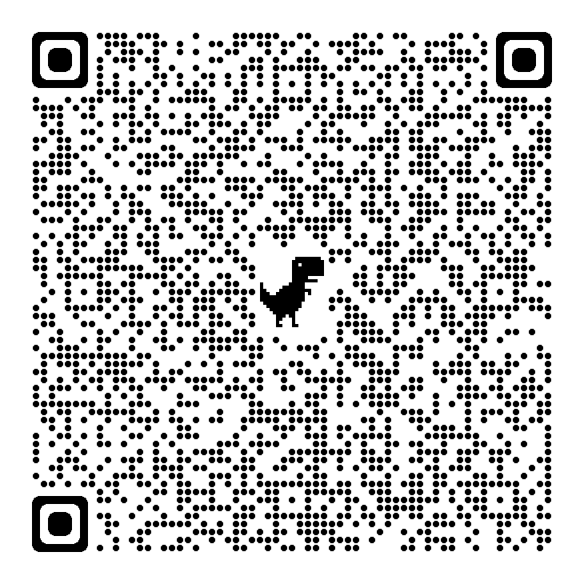

**TASK 3 – EQUALITY, DIVERSITY & INCLUSION**

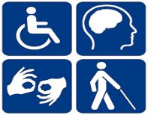

1. **Describe the importance of not discriminating against clients with illnesses and disabilities (Refer to the Disability Discrimination Act)** <https://www.gov.uk/definition-of-disability-under-equality-act-2010>

**Consider – are all disabilities visible – True or False (please circle)**

………………………………………………………………………………………………………………………………………………………………………………………………………………………………………………………………………………………………………………………………………………………………………………………………………………………………………………………………………………………………………………………………………………………………



1. **Explain the legal consequence of gaining a signed consent (i.e. signature) prior to treatment**

**(Use link to guide you** [**Click Here**](https://www.google.com/search?q=signed+consent+before+a+beauty+treatment&rlz=1C1GCCB_enGB1091GB1091&oq=signed+consent+before+a+beauty+treatment&gs_lcrp=EgZjaHJvbWUyCwgAEEUYChg5GKABMgYIARBFGEDSAQg2MjkwajBqNKgCALACAA&sourceid=chrome&ie=UTF-8&safe=active&ssui=on) **)**

………………………………………………………………………………………………………………………………………………………………………………………………………………………………………………………………………………………………………………………………………………………………………………………………………………………………………………………………………………………………………………………………………………………………

**Task 4 - Client Data**

**Use this link to guide you with the questions below: -** <https://www.gov.uk/data-protection>

**C:\temp\Temporary Internet Files\Content.IE5\5FSMULNB\MC900054865[1].wmf**

1. **Explain the importance of correct storage of client records in relation to GDPR (General Data Protection Regulation)**

………………………………………………………………………………………………………………………………………………………………………………………………………………………………………………………………………………………………………………………………………………………………………………………………………………………………………………………………………………………………………………………………………………………………



1. **Explain how to complete client records and the reasons for keeping records of treatments and gaining client signatures.**

<https://www.beautyandhairdressing.co.uk/salon-record-keeping.html#:~:text=Each%20client%20should,to%20your%20clients>.

……………………………………………………………………………………………………………………………………………………………………………………………………………………………………………………………………………………………………………………………………………………………………………………………………………………………………………………………………………………………………………………………………………………………

**Task 5 - Personal Presentation of a Therapist**

**The task: - Design and create an A4 professional poster (in colour) & to include the following A-D:**

***\*\* Use the code of conduct on page 12 to assist you in completing this task\*\****

|  |  |
| --- | --- |
| **Question** | **Please follow the instructions below and complete questions A-D in an A4 poster format on 1 side only.** |
| **A.** | Title your A4 Poster: **G20 – Task 4 Poster of a Professional Therapist created by…… (include your name)**  Source an image of a beauty therapist in uniform, head to toe complying with the code of conduct (on page 12)  The therapist should have the correct uniform, hair, makeup/lashes, jewellery, footwear & nails. |
| **B.** | **Include at least eight ‘Red** outlined text boxes’ on your poster explaining how a professional therapist should look/present themselves, from head to toe and state why this is important when working in the salon; **(Number your text boxes & include your description in red font).** |
| **C.** | **Include at least three ‘Blue** text boxes’ on your poster explaining how a professional therapist should behave/conduct themselves in the workplace/salon at all times and **explain why this is important**; **(Number your text boxes & include your description in blue font).** |
| **D.** | **Include at least three ‘Green** text boxes’ on your poster explaining three topics (referred to as ‘Professional ethics’) that you would not discuss with your client and explain why; **(Number your text boxes & include your description in green font).** |

**Dress Code and Code of Conduct 2024-2025**

***IMPORTANT:*** *A professional appearance gives your client confidence in your ability as a therapist and is required by the awarding body; VTCT and the Inspire Salon.*

|  |  |
| --- | --- |
| **Uniforms** | A professional standardised uniform (tunic, trousers, cardigan, brogues and Scrunchie) must be worn at all times. It is your responsibility to ensure it is clean, laundered and free from creases.  A fob watch and name badge must be worn at all times. Name badge on the left and fob watch on the right. |
| **Footwear** | Shoes: Clean Leather brogues that are ordered as part of the uniform must be worn in the clinics to comply with Health and Safety.  Socks or Pop Socks: Colour: **Flesh, black or navy ONLY.** |
| **Hair** | Secured away from the face in either a tidy bun using a donut and secured with the scrunchie to match your uniform or a scalp plait with no loose strands. |
| **Make-up & Eyelashes** | Professional make-up should be worn at all times. Heavy make-up and eyelash extensions are **not** permitted in the clinics. |
| **Nails** | Manicured, short, clean and free from varnish. |
| **Jewellery** | A maximum of **two** studs may be worn on the ear lobe, no larger than 5mm in diameter.  Cartilage piercings must be discreet; alternatively, clear stud retainers may be worn. A wedding band may also be worn. |
| **Tattoos** | All visible tattoos must be covered at all times with fresh white or flesh coloured Tubi-grip. |
| **Perfume** | Light subtle fragrance should be worn. Avoid strong overpowering fragrances. |
| **Personal Hygiene** | Regular bathing and anti-perspirant/deodorant should be worn at all times to prevent body odour occurring. |
| **Oral Hygiene** | Regular brushing will prevent decay and bad breath. Avoid spicy foods where possible to prevent bad breath occurring. |
| **Smoking** | Avoid smoking whilst wearing your uniform as it causes strong odours. This will prevent both bad breath and unpleasant odours clinging to your uniform. |
| **Phones** | Mobile phones are not permitted in the clinics unless requested by the lecturer.  Mobile phones should remain in your lockers.  It is the therapist’s responsibility to ensure that their client/s turn their mobile device on to ‘silent’ prior to entering the clinics and refrain from taking any calls until exiting the clinics to avoid disrupting the ambience of the Clinic. |
| **Attendance & Punctuality** | All therapists will adhere to the Colleges minimum attendance requirements of 100%. Therapists will arrive at least five minutes prior to the lesson starting to ensure a punctual start. |
| **Safeguarding** | Lanyards must be worn when entering and exiting the Clinics to safeguard all therapists/Clients. Lanyards may be removed during the session for Health and Safety purposes however a magnetic name badge must be visible. All visitors and clients must display a Stamford Colleges visitor’s badge at all times. |
| **General Behaviour** | Team work, positive attitude, respect, manners and professionalism should be promoted at all times. All therapists will strive to meet homework deadlines and set SMART Targets in each lesson to stretch and challenge themselves, preparing them for further education or industry. |
| **Beauty Kit & Stationery** | Your **own** professionally labelled and sanitised beauty kit must be brought to all lessons as well as your subject folder, homework, diary and relevant stationery. |
| **Food & Drink** | Only bottled water is allowed in the Clinics, with the exception of a range of hot drinks for clients. |
| **Professional Ethics** | It is important to remain professional and avoid certain topics whilst performing treatments on clients. To do this, topics that should be avoided, include; sexual orientation/relationships, religion, politics, drug and alcohol. This should prevent any conflicts of opinions and prevent any misunderstandings or disagreements occurring. |

**ADDITIONAL NOTES**