**LEVEL 3**

**NVQ Level 3 Diploma in Beauty Therapy Massage**

**EKU & G22 - Workbook 2024-2025**

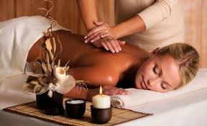

**NAME: ……………………………………………**

**GROUP: Diamonds**

**Issue Date: Monday 1st July 2024**

**Submission Date: Wednesday 4th September**

**INTRODUCTION**

As part of the beauty therapy level 3 qualification it is essential that as a therapist you have knowledge and understanding of certain elements which will cover aspects of each subject area.

With this knowledge you will be able to apply this to your practical element and gain the confidence and professionalism required for when you work in the industry.

The outcome of this workbook is to fully complete all the tasks and this will assist with your learning journey. This **booklet will be required as evidence** **(G22/EKU)** and will be filed with your core units of your portfolio.

Ensure that you complete ALL the tasks in full and answers are detailed. Also, check throughout for spelling, grammar, punctuation, so proof read your work in terms of presentation.

C:\temp\Temporary Internet Files\Content.IE5\5FSMULNB\MC900437990[1].wmf

Happy learning

**OUTCOMES**

For every outcome you must complete each task with the relevant questions fully to meet the criteria.

Remember to proof read your work, checking for spelling, grammar and punctuation throughout, also ensuring you use the correct terminology.

* **Task 1** – Legal responsibilities (questions 1-3)
* **Task 2** – Procedures to safely control work operations (questions 1-2)
* **Task 3** – Working with Minors (questions 1-4)
* **Task 4** – Client Data (questions 1-2)
* **Task 5** – Hygiene & organisational requirements (questions 1-4)
* **Task 6** – Consultation with clients (questions 1-5)
* **Task 7** – Contraindications (questions 1-2)
* **Task 8** – Adaptations (questions 1-3)
* **Task 9** – Aftercare (questions 1-2)
* **Task 10** – Skin Characteristics & postural faults (questions 1-5)

**Note:** **Answers must be detailed and not bullet points**

# Glossary of assignment words:

**Explain** give reasons for, illustrate the meaning of, account for (in terms of a theory or rationale), make clear and intelligible

**TASK 1 - LEGAL RESPONSIBILITIES**

1. **Research** each of the following work acts & then **describe** each one in detail, using beauty therapy examples to enhance your answer. Use the links below to help you with your research

<https://www.fsb.org.uk/resources-page/health-and-safety-hair-and-beauty-salon.html>

<https://www.slideshare.net/slideshow/health-and-safety-legislation-39142564/39142564?from_search=0>

<https://www.slideshare.net/slideshow/core-hazards-and-risks/39142716#1>

|  |  |
| --- | --- |
| **WORK ACT** | **DESCRIPTION** |
| Health & safety at Work Act | *Definition*  *Example* |
| Manual handling | *Definition*  *Example* |
| Personal Protective Equipment | *Definition*  *Example* |
| COSHH | *Definition*  *Example* |
| Electricity at Work Act | *Definition*  *Example* |
| Portable Appliance Testing | *Definition*  *Example* |
| First Aid | *Definition*  *Example* |
| RIDDOR | *Definition*  *Example* |
| Fire Precaution Act | *Definition*  *Example* |
| Liability Insurance | *Definition*  *Example* |
| Risk Assessment | *Definition*  *Example* |
| Data Protection (GDPR) | *Definition*  *Example* |

1. **Explain your responsibilities under the local authority licensing regulations, for yourself (therapist) and your premises (salon)**

[**Click Here**](https://www.profitableventure.com/uk/license-start-beauty-salon/#:~:text=What%20Licenses%20are,off%2Dstage%20effects)

………………………………………………………………………………………………………………………………………………………………………………………………………………………………………………………………………………………………………………………………………………………………………………………………

1. **Explain the importance of not discriminating against clients with illnesses & disabilities and why.**

**Are all disabilities visual, consider this in your answer** <https://www.gov.uk/definition-of-disability-under-equality-act-2010>

………………………………………………………………………………………………………………………………………………………………………………………………………………………………………………………………………………………………………………………………………………………………………………………………

**TASK 2 - Procedures to safely control work operations (Link to Outcome 4 / G22)**

1. **Explain in detail, the difference between a HARZARD, RISK AND CONTROL and give 3 beauty example of each one.**

**Explain a hazard: -**

**Example 1.**

**Example 2.**

**Example 3.**

**Explain a risk: -**

**Example 1.**

**Example 2.**

**Example 3.**

**Explain control: -**

**Example 1.**

**Example 2.**

**Example 3.**

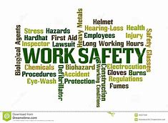

**2a. Describe what type of information is available from the below acts.**

* **RIDDOR**
* **COSHH**
* **GDPR**
* **Health & Safety**
* **First Aid**

**2b. Why are these reports and records required for the workplace & why are these important within a salon:-**

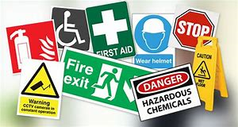

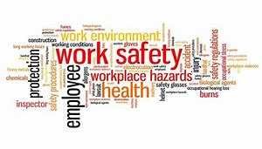

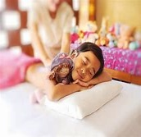**TASK 3 - WORKING WITH MINORS**

1. **State the age at which an individual is classed as a minor in the UK and how this differs nationally i.e. Scotland, Ireland & Wales**

……………………………………………………………………………………………………………………………………………………………………………………………………………………………………………………………………………………………………………………………………………………………………………………

1. **Explain why minors should not be given a treatment without informed and signed parental or guardian consent**

……………………………………………………………………………………………………………………………………………………………………………………………………………………………………………………………………………………………………………………………………………………………………………………

1. **Explain why it is important when treating minors under the age of 16, to have parent present**

……………………………………………………………………………………………………………………………………………………………………………………………………………………………………………………………………………………………………………………………………………………………………………………

1. **Explain the legal significance of gaining signed informed consent to a treatment**

……………………………………………………………………………………………………………………………………………………………………………………………………………………………………………………………………………………………………………………………………………………………………………………

**TASK 4 - Client Data**

**C:\temp\Temporary Internet Files\Content.IE5\5FSMULNB\MC900054865[1].wmf**

1. **Explain the importance of correct storage of client records in relation to GDPR**

………………………………………………………………………………………………………………………………………………………………………………………………………………………………………………………………………………………………………………………………………………………………………………………………………………………………………………………………………………………………………………………………………………………………

1. **Explain how to complete client records and the reasons for keeping records of treatments, and gaining client signatures.**

………………………………………………………………………………………………………………………………………………………………………………………………………………………………………………………………………………………………………………………………………………………………………………………………………………………………………………………………………………………………………………………………………………………………

**TASK 5 - Hygiene & organisational requirements**

1.  **Explain your responsibilities and reasons for maintaining personal hygiene & PPE in line with industry standards**

a) personal hygiene and appearance

b) PPE

1. **Explain the organisations (Stamford College) requirements for client preparation & for treatment area maintenance before a treatment**
2. Client preparation
3. Treatment area maintenance
4. 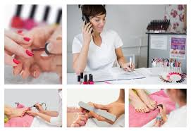**Explain the organisations Level 3 treatment times for treatments (***List all the L3 treatments & the timings)*

**Describe the importance of completing the treatment in a commercially viable time**

1. 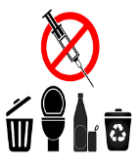**Explain the manufactures and organisational requirements for waste disposal (consider both general & clinical waste)**

**TASK 6 - Consultation with Clients**

1. 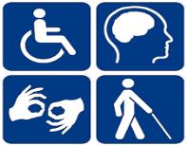**Explain how to use effective consultation techniques when communicating with clients in the following groups-**
2. **different cultural and religious backgrounds**
3. **ages**
4. **disabilities**
5. **genders**

……………………………………………………………………………………………………………………………………………………………………………………………………………………………………………………………………………………………………………………………………………………………………………………

…………………………………………………………………………………………………………………………………………………………………………………………

1. **Explain why it is important to encourage and allow time for clients to ask questions**

………………………………………………………………………………………………………………………………………………………………………………………………………………………………………………………………………………………………………………………………………………………………………… ……………………………………………………………………………………………………………………………………………………………………………………



1. **Explain the importance of questioning clients to establish any contra-indications to head and body massage treatments**

………………………………………………………………………………………………………………………………………………………………………………………………………………………………………………………………………………………………………………………………………………………………………………………………………………………………………………………………………………………………………………………………………………………………………………

1. **Explain why it is important to record client’s responses to questioning & the legal significance of this.**

…………………………………………………………………………………………………………………………………………………………………………………………………………………………………………………………………………………………………………………………………………………………………………

……………………………………………………………………………………………………………………………………………………………………………………



1. **Explain how to give effective advice and recommendations to clients.**

………………………………………………………………………………………………………………………………………………………………………………………………………………………………………………………………………………………………………………………………………………………………………………………………………………………………………………………………………………………………………………………………………………………………………………

**TASK 7 - Contraindications**

1. **Explain the reasons why it is important to encourage clients with contra-indications to seek medical advice**

………………………………………………………………………………………………………………………………………………………………………………………………………………………………………………………………………………………………………………………………………………………………………………………………………………………………………………………………………………………………………………………………………………………………………………

1. **Explain the importance of and reasons for, not naming specific contraindications when encouraging clients to seek medical advice**

………………………………………………………………………………………………………………………………………………………………………………………………………………………………………………………………………………………………………………………………………………………………………………………………………………………………………………………………………………………………………………………………………………………………………………

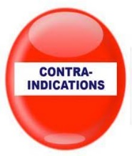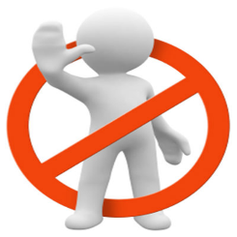

**TASK 8 - Adaptations**

1. **Explain why it is important to maintain the client’s modesty and privacy before, during & after a treatment**

……………………………………………………………………………………………………………………………………………………………………………………………………………………………………………………………………………………………………………………………………………………………………………………………………………………………………………………………………………………………………………………………………………………………………………………………………………………………………………………………………………………………………………………………………………………

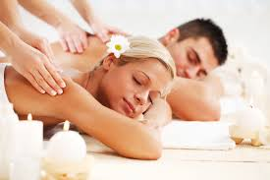

1. **Explain how to adapt massage treatments for male and female clients (consider body type, pressure, massage mediums, areas to avoid)**

[**https://www.salongeek.com/threads/treating-male-clients.45430/**](https://www.salongeek.com/threads/treating-male-clients.45430/)

……………………………………………………………………………………………………………………………………………………………………………………………………………………………………………………………………………………………………………………………………………………………………………………………………………………………………………………………………………………………………………………………………………………………………………………………………………………………………………………………………………………………………………………………………………………

**TASK 9 - After Care**

1. **Explain the relationship between lifestyle patterns and the effectiveness of treatment & what are the benefits from improving their lifestyle**

………………………………………………………………………………………………………………………………………………………………………………………………………………………………………………………………………………………………………………………………………………………………………………………………………………………………………………………………………………………………………………………………………………………………………………

1. **Explain how eating and exercise habits can affect the effectiveness of treatments**

…………………………………………………………………………………………………………………………………………………………………………………………………………………………………………………………………………………………………………………………………………………………………………



**TASK 10 - Contraindications & postural assessments (Mood Board Task)**

**Create a mood board using IT, of which the Title is :- Postural & Skin Conditions created by ……………………**

* Include detailed text boxes
* Number each text box and include images for each question
* Ensure your answers are detailed.

1. **Explain the 4 main postural conditions that maybe present on a client**

**Explain how to adapt and change the massage routines according to each of the conditions**

<https://treatingscoliosis.com/blog/understanding-kyphosis-lordosis-and-scoliosis/>

1. **Explain how to recognise different skin type & characteristics**

**(R**efer to your level 2 knowledge of skin care i.e. 5 main skin types with 4 characteristics of each – normal, oily, dry, combination & sensitive)

1. **Explain the causes and symptoms of hyperaemia**

**Explain the causes and symptoms of erythema**

1. **Explain what is RSI**
2. 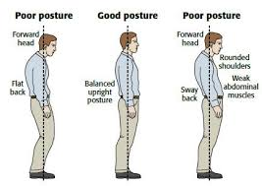**Explain why it is important to maintain your own correct posture during treatments & to complete stretching exercises to prevent injury including RSI**