Summer Project for the T-Level Digital Production, Design & Development

Thank you for accepting the offer of a place on the T-level Digital Production, Design and Development course that starts at Stamford College in September 2024.

Due to the significant amount of coding involved on the course I would like you to complete a free, online course BEFORE you start on the course, as it will help you develop an understanding of coding in Python.

- You will need to create a free Codecademy account at https://www.codecademy.com/
- Complete the course ‘Learn Python 2’, which should take around 17 hours, as seen below:
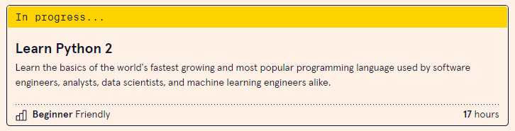
- Once you have completed the course, take a screenshot of the progress bar (should say 100%) and email it to me at alan.day@ieg.ac.uk

- You must also create a Python program that will meet the following requirements
A computer games club has commissioned you as a Junior Software Developer to write a program that will help the club keep a record of players’ scores and provide statistics.

The program should allow the user to record a player’s scores and display statistics.

You need to create a program that will allow the user to enter the following information:
- the player ID
- the number of games played
- the score achieved in each game
- the length of time taken in minutes for each game.

The program should then:
- display the player ID
- display the player’s highest score
- display the average length of time spent playing

Information

You are provided with this information to use when designing and developing your program:
- minimum and maximum number of games played
- minimum and maximum time for each game

Minimum and maximum number of games played

Minimum number of games = 5
Maximum number of games = 10

Minimum and maximum time for each game

Minimum time = 5 minutes
Maximum time = 60 minutes
Note – time must be entered and displayed as whole minutes.

- Once you have written a working program, you can:

  - email me the source code as a Notepad (.TXT) file at alan.day@ieg.ac.uk

The progress bar from Codecademy and the source code from the Python program will form part of the requirements, for what we call Steps-to-Success, which we use to ensure you are on the correct programme of study. This process will also include another short programming test in week 4 of the course.

I hope you get the GCSE results that you deserve and I look forward to meeting you in September.

Alan Day
Course Tutor for T-Level Digital Production, Design and Development

