## Activity: Assessing Your Sport Psychological Skills

One of your units will be Sports Psychology. How your mind functions in stressful conditions is extremely important to succeed in sport.

This activity will help you assess yours/or someone else’s ability to manage your sporting ability.

**Instructions:**

Either complete the questionnaire for yourself or interview someone else. Remember you have to think of yourself when playing sport.

The following are statements that athletes have used to describe their experiences. Please read each statement carefully, and then recall as accurately as possible how often you experience the same thing. There are no right or wrong answers. Do not spend too much time on any one statement.  
  
Please circle how often you have these experiences when playing sports.

|  |  | 0 | 1 | 2 | 3 |
| --- | --- | --- | --- | --- | --- |
| 1 | On a daily or weekly basis, I set very specific goals for myself that guide what I do. | Almost never | Sometimes | Often | Almost always |
| 2 | I get the most out of my talent and skill. | Almost never | Sometimes | Often | Almost always |
| 3 | When a coach or manager tells me how to correct a mistake I've made, I tend to take it personally and feel upset. | Almost never | Sometimes | Often | Almost always |
| 4 | When I'm playing sports, I can focus my attention and block out distractions. | Almost never | Sometimes | Often | Almost always |
| 5 | I remain positive and enthusiastic during competition, no matter how badly things are going. | Almost never | Sometimes | Often | Almost always |
| 6 | I tend to play better under pressure because I think more clearly. | Almost never | Sometimes | Often | Almost always |
| 7 | I worry quite a bit about what others think of my performance. | Almost never | Sometimes | Often | Almost always |
| 8 | I tend to do lots of planning about how to reach my goals. | Almost never | Sometimes | Often | Almost always |
| 9 | I feel confident that I will play well. | Almost never | Sometimes | Often | Almost always |
| 10 | When a coach or manager criticizes me, I become upset rather than feel helped. | Almost never | Sometimes | Often | Almost always |
| 11 | It is easy for me to keep distracting thoughts from interfering with something I am watching or listening to. | Almost never | Sometimes | Often | Almost always |
| 12 | I put a lot of pressure on myself by worrying about how I will perform. | Almost never | Sometimes | Often | Almost always |
| 13 | I set my own performance goals for each practice. | Almost never | Sometimes | Often | Almost always |
| 14 | I don't have to be pushed to practice or play hard; I give 100%. | Almost never | Sometimes | Often | Almost always |
| 15 | If a coach criticizes or yells at me, I correct the mistake without getting upset about it. | Almost never | Sometimes | Often | Almost always |
| 16 | I handle unexpected situations in my sport very well. | Almost never | Sometimes | Often | Almost always |
| 17 | When things are going badly, I tell myself to keep calm, and this works for me. | Almost never | Sometimes | Often | Almost always |
| 18 | The more pressure there is during a game, the more I enjoy it. | Almost never | Sometimes | Often | Almost always |
| 19 | While competing, I worry about making mistakes or failing to come through. | Almost never | Sometimes | Often | Almost always |
| 20 | I have my own game plan worked out in my head long before the game begins. | Almost never | Sometimes | Often | Almost always |
| 21 | When I feel myself getting too tense, I can quickly relax my body and calm myself. | Almost never | Sometimes | Often | Almost always |
| 22 | To me, pressure situations are challenges that I welcome. | Almost never | Sometimes | Often | Almost always |
| 23 | I think about and imagine what will happen if I fail or screw up. | Almost never | Sometimes | Often | Almost always |
| 24 | I maintain emotional control regardless of how things are going for me. | Almost never | Sometimes | Often | Almost always |
| 25 | It is easy for me to direct my attention and focus on a single object or person. | Almost never | Sometimes | Often | Almost always |
| 26 | When I fail to reach my goals, it makes me try even harder. | Almost never | Sometimes | Often | Almost always |
| 27 | I improve my skills by listening carefully to advice and instruction from coaches and managers. | Almost never | Sometimes | Often | Almost always |
| 28 | I make fewer mistakes when the pressure is on because I concentrate better. | Almost never | Sometimes | Often | Almost always |

***Scoring***

This is the Athletic Coping Skills Inventory (ACSI), a measure of an athlete's psychological skills, developed by Smith et al. (1994). Determine your score on the following subscales by adding the scores on the question numbers identified. Also, note the following numerical scales associated with your ratings.  
  
0 = almost never  
1 = sometimes  
2 = often  
3 = almost always  
  
**Finally, note that an * after a question number signifies a reverse-scored item (that is, 0 = almost always, 3 = almost never, and so on).**  
______***Coping With Adversity***: This subscale assesses if an athlete remains positive and enthusiastic even when things are going badly, remains calm and controlled, and can quickly bounce back from mistakes and setbacks.  
(Sum scores on questions 5, 17, 21, and 24, and place the total in the blank provided.)   
______***Coachability:*** Assesses if an athlete is open to and learns from instruction, and accepts constructive criticism without taking it personally and becoming upset.  
(Sum scores on questions 3*, 10*, 15, and 27, and place the total in the blank provided.)  
______***Concentration:*** This subscale reflects whether an athlete becomes easily distracted, and is able to focus on the task at hand in both practice and game situations, even when adverse or unexpected situations occur.  
(Sum scores on questions 4, 11, 16, and 25, and place the total in the blank provided.)  
______***Confidence and Achievement Motivation***: Measures if an athlete is confident and positively motivated, consistently gives 100% during practices and games, and works hard to improve his or her skills.  
(Sum scores on questions 2, 9, 14, and 26, and place the total in the blank provided.)  
______***Goal Setting and Mental Preparation***: Assesses whether an athlete sets and works toward specific performance goals, plans and mentally prepares for games, and clearly has a game plan for performing well.  
(Sum scores on questions 1, 8, 13, and 20, and place the total in the blank provided.)  
______***Peaking Under Pressure***: Measures if an athlete is challenged rather than threatened by pressure situations and performs well under pressure.  
(Sum scores on questions 6, 18, 22, and 28, and place the total in the blank provided.)   
______***Freedom From Worry***: Assesses whether an athlete puts pressure on him- or herself by worrying about performing poorly or making mistakes; worries about what others will think if he or she performs poorly. (Sum scores on questions 7*, 12*, 19*, and 23*, and place the total in the blank provided.)

***_____ Total score or sum of subscales***  
  
Scores range from a low of 0 to a high of 12 on each subscale, with higher scores indicating greater strengths on that subscale. The score for the total scale ranges from a low of 0 to a high of 84, with higher scores signifying greater strength.

Now can you visualise your results on the radar diagram below.

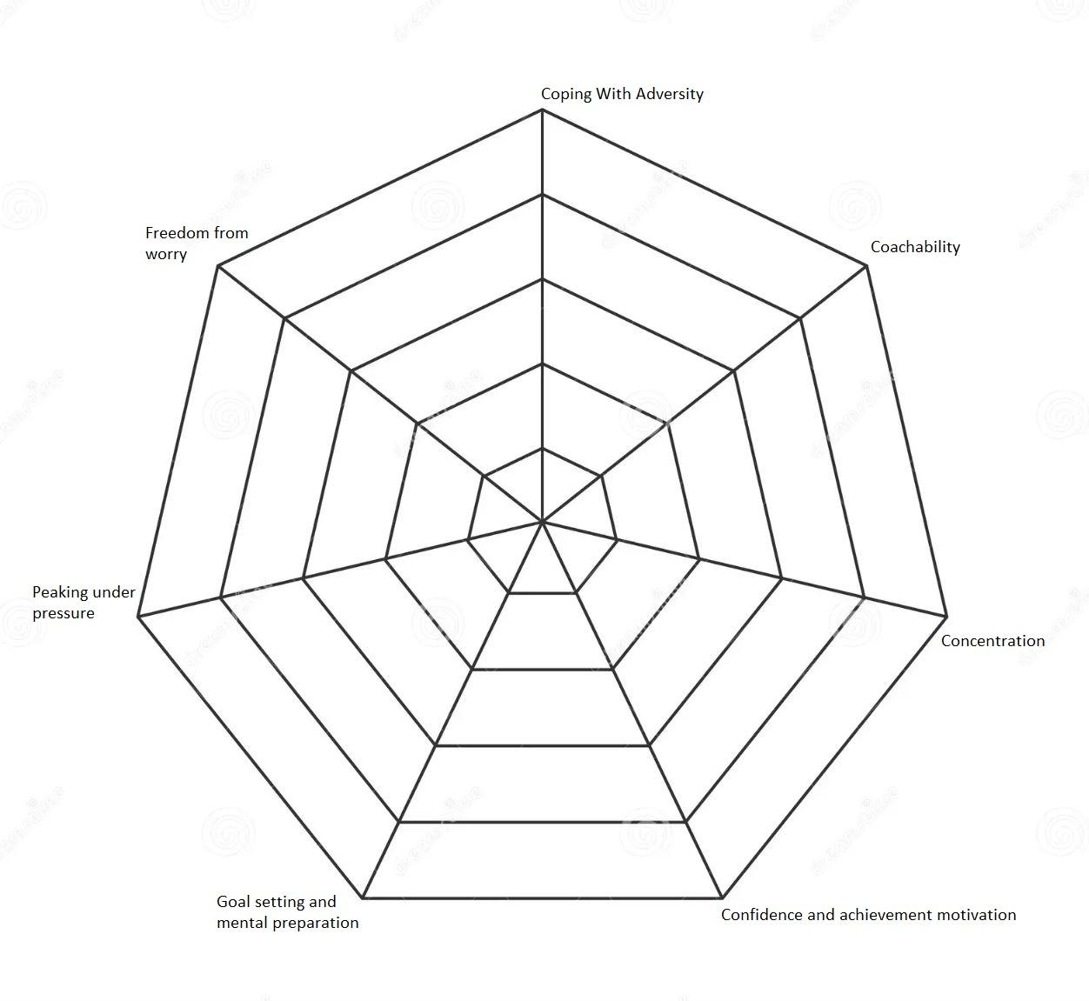

There are many methods that can be used to develop your coping skills in sport. Do some research and find out about the following:

**State what it is and then how it can be used to improve your sports performance.**

| Goal setting |
| --- |
| Arousal control |
| Performance profiling |
| Imagery |
| Self-talk |