Summer Assignment

This math’s practice paper forms part of the summer assignment that will assist and prepare you for the Electrical Diploma Level 3 course

It is a mandatory requirement to come on the course as the learning will start where this level of math’s and formula / Equation transformation finishes.

It has been found in previous years that without this practice prior to the course starting that the 1st progress test which happens within the first six weeks and is a mandatory pass to stay on the course has been found to be extremely difficult but that is the nature of this very demanding but worthwhile course.

If it is not completed you will not meet the conditions of your course offer as this demonstrates you are not sincere and genuine in completing the Electrical L3 course and will not be invited to attend.

We wish to inform all students prior to starting the course there are three (3) progression tests in the first six (6) weeks that must be passed to continue on the course prior to registration with the awarding body

CHAPTER 1

Fundamental CONCEPTS

Numbers and Symbols

Natural numbers, for example 1, 2, 3, etc. are called positive integers. Positive fractions such as ½, ¼, ¾, together with these positive integers, constitute positive rational numbers.

Numbers less than zero are called negative numbers.

Numbers such as √2, √3 are called irrational numbers because they cannot be represented by the quotient of two integers.

Together all the above kinds of numbers constitute the broad class of numbers known as real numbers.

The number of units a point is from zero, regardless of its direction, is called the absolute value.
For example, the absolute value of -14 is 14. In written form is │-14│= 14.

LAWS OF SIGN

FIRST LAW To add two numbers with like signs, add their absolute values and prefix their common sign to the result

+4 + (+4) = +8

SECOND LAW To add two signed numbers with unlike signs, subtract the smaller absolute value from the larger and prefix the sign of the number with the larger absolute value to the results.

8 + (-2) = +6, -12 + (+5) = -7

THIRD LAW To subtract one signed number form another, change the sign of the number to be subtracted and prefix the sign of the number with the larger absolute values.

-3 – (+6) = -9 -8 – (-2) = -6

FOURTH LAW To multiply (or divide) one signed number by another, multiply ( or divide) their absolute values; then if the numbers have like signs, prefix the plus sign to the result; if they have unlike signs prefix the minus sign to the result.

(-4) x (-4) = +16 (-2) x (+7) = -14

THE COMMUTATIVE, ASSOCIATIVE AND DISTRIBUTIVE LAWS

COMMUTATIVE LAW OF MULTIPLICATION

The product of two real numbers is the same no matter in what order they are multiplied.
ab = ba

ASSOCIATIVE LAW OF MULTIPLICATION

The product of three or more numbers is the same no matter in what manner they are grouped.
a(bc) = (ab)c = b(ca)

COMMUTATIVE LAW OF ADDITION

The sum of two numbers is the same no matter which order they are added.
a + b = b + a

ASSOCIATIVE LAW OF ADDITION

The sum of three or more numbers is the same no matter in what manner they are grouped.
(a + b) + c = a + (b + c)

DISTRIBUTIVE LAW

a (b + c) = ab + ac

BODMAS

There must be clear guidelines which allows for accurate calculation involving various mathematical operations.

The sequence of doing these mathematical operations is referred to by the mnemonic: BODMAS.

Brackets

Orders (powers and roots)

Division

Multiplication

Addition

Subtraction

In simple terms, ALL arithmetic calculations must be carried out in the order above.

Examples:

1) 2(7−2)−4×6+3 = 2×5−4×6+3 = 10−24+3 = −17

2) 3(7−5)−4(2−3) = 10 = − 5
4×(3−5) - 8 4

Exercise 1.1

Evaluate the following:

(1) (12-5)² + 3 x 4 (2) 4(6-2) + (3 x 8)

(3) (9 x3) – (15 - 8) (4) (-8) – (-4)³ + (+9)

(5) (-3) + (-6) – (-9) (6) (+4) – (+8) – (-9)

(7) $\frac{(+\text{12})×(−5)}{(+\text{10})×(−3)}$ (8) $\frac{(8×3)×(−3)}{(−\text{12})}$

(9) Which of the following has the largest absolute value -8, 3, 16, -26, -35?

Decimals

The decimal system of numbering is used throughout the world and as the name implies, (Deci = ten), it is based around the unit of 10.

Decimal places are used to indicate the accuracy to which the answer should appear. A number rounded to 3 decimal places would indicate that the accuracy of the answer required is to be fixed to 3 numbers after the decimal point. If the number is a whole number, or there are less than 3 numbers after the decimal point, zeros are added to fill out to 3.

Examples

1. 2.347 (2d.p.) = 2.35 4. 14.694 (2d.p.) = 14.69

2. 14.697 (2d.p.) = 14.70 5. 0.0685 (2s.f.) = 0.069

3 15.48 (2s.f.) = 15 6. 378000 (2s.f.) = 380000

Significant Figures

This refers to all the numbers regardless of which side of the decimal point they fall. Rounding is carried out in the usual way. e.g. to round a number to 3 significant figures, count from the left. If the number is greater than 1 (e.g. 1.05), then ALL the figures from the left are significant. If it is less than 1 (e.g. 0.9), then the first significant figure is the 9, as zero bears no significance. If the zero falls to the right of another significant figure, then it becomes significant as it indicates the position in our number counting scale (e.g. 50,045 indicates 5 lots of 10,000, zero 1000’s, zero hundred, 4 tens and 5 units; hence the significance of the zero’s)

Use of significant figures. These are commonly used in everyday life. e.g. You may travel 12,304 miles in a year, but you would tend to say that you do about 12,000 miles per year. A Big Mac meal may cost £2.99, but you would say that it cost £3.00. e.g. 52480 would be expressed as 52000 to 2 significant figures, 52500 to 3 significant figures, or 52480 to 4 significant figures.

Example

To 2 significant figures: 0.0000956 = 0.000096
0.1000005 = 0.10
1.00023 = 1.0
1.16 = 1.2
50005 = 50000
50600 = 51000

Standard Form

Standard form is a method for displaying very large or very small numbers in a standard format.
(Note - A STANDARD FORM NUMBER MUST BE BETWEEN 1 & 10)

Worked examples

Write in standard form

1. 0.00000895 = 8.95 x 10 ^{–6} i.e. the decimal place is moved to just after the
first whole number, and the number of places that you will have to move it to return to the original number is quoted as x 10 ^{–6} (in this case)

2. 12 900 000 = 1.29 x 10 ⁷

Accuracy of Answers

The number 52 is considered to be correct to 2 significant figures. In reality, it could well have been rounded up from 51.6 or down from 52.4 or any number between 51.5 – 52.5. Hence to be expressed accurately, it should be expressed as 52 ± 0.5.

Similarly, 0.1370 is considered to be accurate to 4 significant figures, and lies between 0.1370 ± 0.00005.

In engineering problems, the accuracy of an answer needs to be considered to assess the significance of any inaccuracies. For example, consider an electrical resistance of 52 Ω. This may have been a rounded figure, and so could actually fall between 51.5 and 52.5. On the surface this appears to indicate a possible inaccuracy of + 0.5. In reality it may be considerably less, but can be a maximum of 0.5 Ω.

Now consider what would happen if two figures containing an inaccuracy are added.

For Example: (52 + 0.5) + (36 + 0.5)

The greatest value would be the combined greater values of the individual figures.

i.e. (52 + 0.5) + (36 + 0.5) = (52 + 36) + (0.5 + 0.5)
= 88 + 1.0
= 89

Similarly, the smallest value is 88 – 1.0 = 87

Hence the final result lies between 87 & 89, and would be stated 88 + 1.0, a maximum error of 1.0.

Generally, when adding and subtracting numbers, the maximum error of the result may be found by adding the maximum errors of the original numbers.

EXERCISE 1.2

1. Quote to 2 decimal places:

a. 4.9783

- 57.443

- 59.9961

2. Round the following to 4 significant figures:

- 4.5078

b. 0.0793047

c. 79.493

3. Put the following into standard form (use 2 decimal places):

a. 30331.2

b. 563.89

c. 1000

d. 0.0039

e. 0.00000739

PREFIXES

SI units can be made larger or smaller by using appropriate prefixes to denote multiplication or division by a particular quantity. Table 1.2 below illustrates the most common multiples with their appropriate meaning.

Table 1.2
Prefix Symbol | Name | Meaning | Power or Factor
T | Tera | multiply by 1 000 000 000 000 | x 10¹²
G | Giga | multiply by 1 000 000 000 | x 10⁹
M | Mega | multiply by 1 000 000 | x 10⁶
k | kilo | multiply by 1 000 | x 10³
m | milli | divide by 1 000 | x 10⁻³
μ | micro | divide by 1 000 000 | x 10⁻⁶
n | nano | divide by 1 000 000 000 | x 10⁻⁹
p | pico | divide by 1 000 000 000 000 | x 10⁻¹²

examples

(1) 16500 Watts = 16.5 x 10³W = 16.5 kW

- 2467534 Watts = 2.467534 x 10⁶W = 2.468 MW to 3 decimal places

- 0.00845 metres = 8.45 x 10⁻³m = 8.45 mm

- 0.00000236 Joules = 2.36 x 10⁻⁶J = 2.36 μJ

EXERCISE 1.3

Rewrite using the required prefixes:

1. 547380 Watts to MW

2. 0.65485 Joules to mJ

3. 4560000 Joules to MJ

4. 9700 Newtons to kN

PYTHAGORAS’ THEOREM AND ITS USE

Pythagoras’ Theorem states that in a right-angled triangle, the square of the hypotenuse is equal to the sum of the squares of the other two sides.

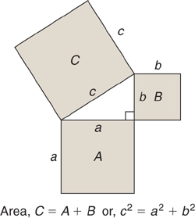

For the triangle shown,

c² = a² + b² or a² = c² - b² or b² = c² - a²

This theorem can be used to find the height of equilateral and isosceles triangles.

An equilateral triangle has all its sides of equal length.
An isosceles triangle has two sides of equal length.

EXAMPLE

Find the height of an isosceles triangle shown in the following diagram that has equal sides of length 13cm and a base length of 10cm.

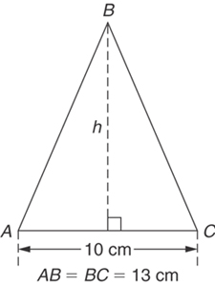

Applying Pythagoras’ theorem and noting that the hypotenuse is opposite the right angle,

→ h² = 13² - 5² = 169 – 25 = 144

→ h = $\sqrt{\text{144}}$ = 12

→ h = 12cm

Note that the height h is always at right angles to the base and meets at the apex. For an isosceles triangle, the height bisects the base.

EXERCISE 1.4

1. For both of the triangles shown in Figure below, find:
(a) the length of sides ‘b’ using Pythagoras’ Theorem (to 2 dp)

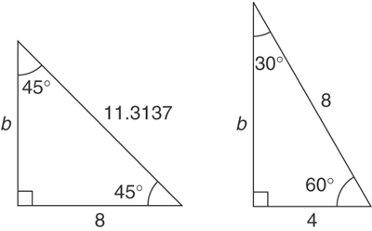

2. In a triangle ABC, angle B is a right angle, AB = 6.92 cm, and BC = 8.78 cm. Find the length of the hypotenuse.

3. In a triangle CDE, D = 90°, CD = 14.83 mm and CE = 28.31mm. Determine the length of DE.

4. A ladder 3.5 m long is placed against a perpendicular wall with its foot 1.0 m from the wall. How far up the wall (to the nearest cm) does the ladder reach?
If the foot of the ladder is now moved 30 cm further away from the wall, how far does the top of the ladder fall?

TRANSPOSITION OF FORMULAE

Transposition is the process by which an equation is manipulated to make a specified part of the equation the subject. Transposition involves applying a series of operations following set rules to permit the equation to be manipulated without changing the relationship between each part. The process involves applying the rules of indices, basic rules of arithmetic, simple factorisation, and the fact that equations remain the same no matter what you do, providing that you apply the same operation to every part of the equation.

The methods used to transpose formulae vary depending on how it is taught. The following methods can be used for guidance:
- Symbols connected as a product
- Symbols connected as a quotient
- Symbols connected by a plus or minus sign
- Formulae containing brackets

Symbols connected as a product

EXAMPLE

Transpose P = IV to make V the subject.

Divide both sides by I:
→ P = IV
I I

→ P = V
I

→ V = P
I

Symbols connected as a quotient

EXAMPLE

Transpose the formula R = V to make V the subject.
I

Multiply both sides by I:
→ R x I = V x I
I

→ R I = V

→ V = I R

EXAMPLE

Transpose the formula mR = PV to make V the subject.
Τ
Cross-multiply:
mR = PV .
1 Τ

→ mRT = PV

→ mRT = PV
P P

→ mRT = V
P

Symbols connected by a Plus or Minus sign

EXAMPLE

Transpose v = u + at for u.

Subtract at from both sides:

→ v – at = u or u = v – at

EXAMPLE

Transpose V = E + IR for I.

Subtract E from both sides:

→ V – E = IR

Divide both sides by R

→ V – E = I
R

or I = V – E
R

Formulae containing brackets

EXAMPLE

Transpose Q = mc (T₂ – T₁) for T₁.

Divide both sides by mc

→ Q = (T₂ – T₁)
mc

Change signs of all terms on both sides of the equation

→ - Q = -T₂ + T₁
mc

Add T₂ to both sides

→ +T₂ – Q = -T₂ + T₁ + T₂
mc

→ T₂ – Q = T₁
mc

or T₁ = T₂ – Q_
mc

EXAMPLE

Transpose I = __V___ for V.
R + x

Multiply both sides by ( R + x ):

→ I (R + x) = V(R + x)
(R + x)

→ I (R + x) = V

or V = I (R + x)

EXAMPLE

Formulae containing Roots and Powers

Transpose E = mgh + ½ mv² for v.

Subtract mgh from both sides:

→ E – mgh = ½ mv²

Multiply both sides by 2:

→ 2 (E –mgh) = mv²

Divide both sides by m:

→ 2 (E –mgh) = v²
m
Take square root of both sides:

→ $\sqrt{2\frac{\left(E−\text{mgh}\right)}{m}}$ = v

or v = $\sqrt{2\frac{\left(E−\text{mgh}\right)}{m}}$
EXAMPLE

Transpose $t=2π\sqrt{\frac{l}{g}}$ for l.

Divide both sides by 2π:

→ $\frac{t}{2π}$ = $\sqrt{\frac{l}{g}}$

Square both sides:

→ [$\frac{t}{2π}$ ]² = $\frac{l}{g}$
Multiply both sides by g:

→ g [$\frac{t}{2π}$ ]² = l

or l = g [$\frac{t}{2π}$ ]²
EXERCISE 1.5

Transpose the following:

1. a + b = c – d – e (for d)

2. x + 3y = t (for y)

3. c = 2πr (for r)

4. y = mx + c (for x)

5. I = PRT (for T)

6. $I=\frac{E}{R}$ (for R)

7. $S=\frac{a}{1−r}$ (for r)

8. F = $\frac{9}{5}$C + 32 (for C)

EXERCISE 1.6

Transpose the following:

a. $\text{ax}+\text{by}=c$ (for y)

b. v² = u² + 2as (for s)

c. $s=\text{ut}+\frac{1}{2}\text{at}$² (for a)

d. $C=\frac{5}{9}\left(F−\text{32}\right)$ (for F)

e. $S=\frac{n}{2}\left(a+1\right)$ (for n)

f. $A=P\left(1+\frac{R}{\text{100}}\right)$ (for R)

g. $S=p\text{rl}+{pr}^{2}$ (for l)

h. $3a=\sqrt{x+2}$ (for x)

i. $E=\frac{\text{Fl}}{\text{Ax}}$ (for x)

j. $A=\frac{3(F−f)}{L}$ (for f)

k. $y=\frac{{\text{AB}}^{2}}{5\text{CD}}$ (for D)

l. $t=2π\sqrt{\frac{L}{g}}$ (for L)

- y = 4ab²c² (for b)

n. R = R₀(1 + αt) (for t)

USING A CALCULATOR

The most modern aid to calculations is the pocket-sized electronic calculator. With one of these, calculations can be quickly performed, correct to about 9 significant figures. The scientific type calculator has made the use of tables and logarithms largely redundant.

Specific procedures will be determined by individual calculator differences. It is essential that you become familiar with the operation of your own calculator, including the use of the more complex functions. As there is no such thing as a ‘standard’ calculator, you will need to ensure that you refer regularly to your own calculator manual. This lesson is intended to give a few pointers, and to allow you to practice. You must get used to the individual problems that your calculators will cause.

This is an example of a scientific calculator showing the relevant functions.

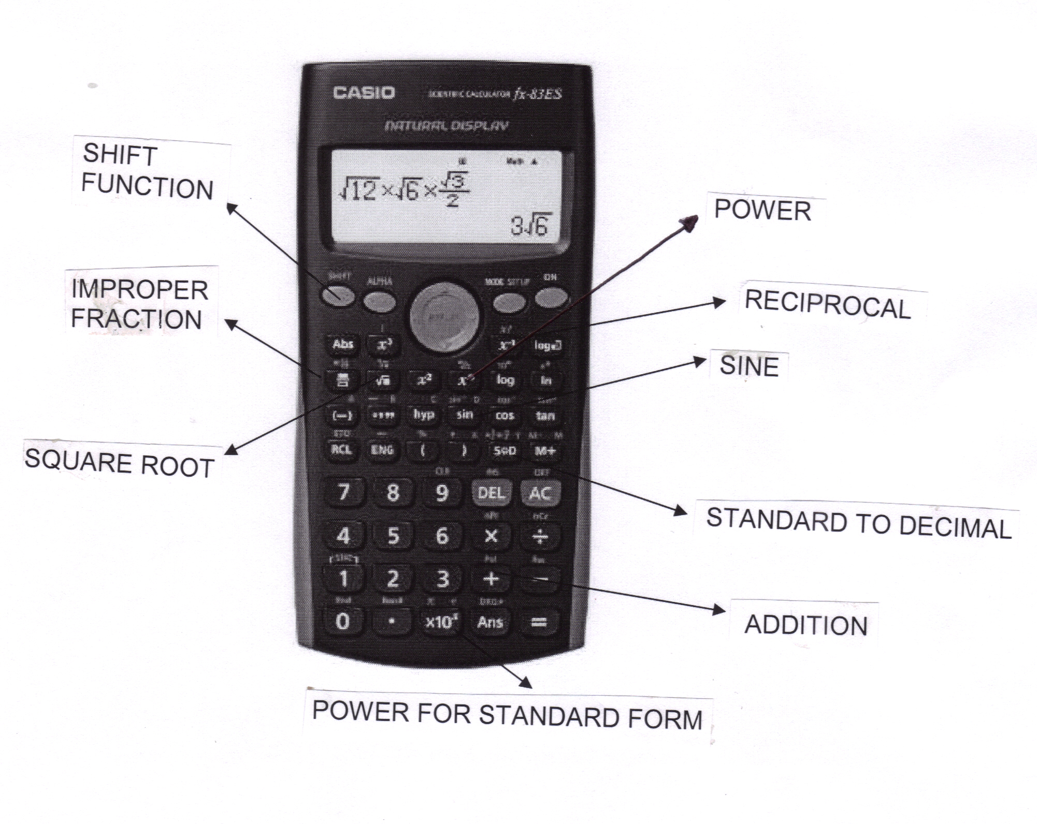

To help you become competent at using your calculator, check your answers to the following problems:

EXAMPLES

Evaluate the following, correct to 3 significant figures:

- 4.7826 + 0.02713 = 4.80973 correct to 3 sig fig = 4.81

- 17.6941 – 11.8762 = 5.8179 correct to 3 sig fig = 5.82

Evaluate the following, correct to 4 decimal places:

3. 46.32 x 97.17 x 0.01258 = 56.6215031 correct to 4 decimal places = 56.6215

4. $\frac{4\text{.}\text{621}}{\text{23}\text{.}\text{76}}$= 0.19448653 correct to 4 decimal places = 0.1945

5. $\frac{1}{\text{52}\text{.}\text{73}}$= 0.01896453 correct to 4 decimal places = 0.0190

Evaluate the following, expressing answer in standard form, correct to 3 decimal places:

- (0.00451)² = 2.03401 x 10⁻⁵ correct to 3 d.p. = 2.034 x 10⁻⁵

- 46.27² – 31.79² = 1130.3088 correct to 3 d.p. = 1.130 x 10³

Evaluate the following, correct to 3 significant figures:

8. $\sqrt{5\text{.}\text{462}}$ = 2.3370922 correct to 3 significant figures = 2.34

9. sin 53° = 0.79863551 correct to 3 sig fig = 0.799

- tan⁻¹ (0.781) = 37.9898° correct to the nearest degree = 38°

EXERCISE 1.7

Use a calculator to evaluate the following correct to 3 decimal places:

1. 3.249²

2. $\sqrt{\text{35}\text{.}\text{46}}$

3. $\frac{1}{\text{48}\text{.}\text{46}}$

4. 43.27 x 12.91

5. 15.76 ÷ 4.329

6. 13.6³

3
7. $\frac{\text{24}\text{.}\text{68}x0\text{.}\text{0532}}{7\text{.}\text{412}}$

8. $\frac{\text{14}\text{.}{\text{32}}^{3}}{\text{21}\text{.}{\text{68}}^{2}}$

9. $\frac{4\text{.}{\text{821}}^{3}}{\text{17}\text{.}{\text{33}}^{2}−(\text{15}\text{.}\text{86}x\text{11}\text{.}6)}$

10. $\sqrt{6\text{.}{\text{921}}^{2}+4\text{.}{\text{816}}^{3}−2\text{.}{\text{161}}^{4}}$

11. (8.291 x 10⁻⁴)³

12. 1 - $\frac{5\text{.}0}{3\text{.}6+7\text{.}\text{49}}$
EVALUATION OF FORMULAE

The statement v = u + at is said to be a formula for v in terms of a, u and t; v, a, u and t are called symbols.

The single term on the left hand side of the equation, v is called the subject of the formulae.

Provided values are given for all the symbols in a formula except one, the remaining symbol can be made the subject of the formula and may be evaluated by using a calculator.

EXAMPLES

Remember to show all working.

- In an electrical circuit the voltage V is given by Ohm’s law, V = IR. Find, correct to 4 significant figures, the voltage when I = 5.36 A and R = 14.76Ω.

SOLUTION

Use formula V = IR

Substitute numerical values into the formula

→ V = 5.36 x 14.76 = 79.1136 V

→ V = 79.11 V correct to 4 sig fig.

2. The surface area A of a hollow cone is given by A = πrl. Determine, correct to 1 decimal place, the surface area when r = 3.0cm and l = 8.5cm.

SOLUTION

Use formula A = πrl

Substitute numerical values into the formula

→ A = π x 3.0 x 8.5 = 80.11061267 cm²

→ A = 80.1 cm² correct to 1 d p

EXERCISE 1.8

1. The area of a triangle is given by the formula A = l b. Evaluate the area when l = 12.4cm and b = 5.37cm. (answer to 3sf)

2. The circumference of a circle is given by the formula C = 2πr. Determine the circumference given r = 8.40mm. (answer to 3sf)

3. The velocity of a body is given by v = u + at. The initial velocity u is measured when time t is 15 seconds and found to be 12m/s. If the acceleration a is 9.81m/s², calculate the final velocity v to 3sf.

4. Calculate the current I in an electrical circuit given I = $\frac{V}{R}$ when the voltage V is measured and found to be 7.2V and the resistance R is 17.7Ω (answer to 3sf).

ANSWERS

EXERCISE 1.1 EXERCISE 1.2

1. 61 1. (a) 4.98
2. 40 (b) 57.44
3. 20 (c) 60.00
4. 65 2. (a) 4.508
5. 0 (b) 0.07930
6. 5 (c) 79.49
7. 2 3. (a) 3.03 x 10⁴
8. 6 (b) 5.64 x 10²
9. -35 (c) 1.00 x 10³
(d) 3.90 x 10⁻³
(e) 7.39 x 10⁻⁶

EXERCISE 1.3

1. 0.54738 MW EXERCISE 1.4
2. 654.85 mJ
3. 4.56 MJ
4. 9.7 kN 1. (a) b=8, and b=6.93
2. 11.18 cm
3. 24.11 mm
4. 3.35 m, 10 cm

EXERCISE 1.5
1. d = c – e – a – b 7. r = 1 - $\frac{a}{S}$

2. y = $\frac{t−x}{3}$ 8. C = $\frac{5(F−\text{32})}{9}$

3. r = $\frac{c}{2π}$

4. x = $\frac{y−c}{m}$

5. T = $\frac{I}{\text{PR}}$

6. R = $\frac{E}{I}$

EXERCISE 1.6

(a) y = $\frac{(c−\text{ax})}{b}$ (k) D = $\frac{{\text{AB}}^{2}}{5\text{Cy}}$

(b) s = $\frac{(v^{2}−u^{2})}{2a}$ (l) L = $\frac{t^{2}g}{4π^{2}}$

(c) a = $\frac{2(s−\text{ut})}{t^{2}}$ (m) b = √ _y_
4ac²
(d) F = $\frac{9C}{5}$+ 32 (n) t = $\frac{R−R_{0}}{{αR}_{0}}$

(e) n = $\frac{2S}{(a+1)}$
(f) R = 100 $\frac{A}{P}−1$

(g) l = $\frac{s}{πr}−r$

(h) x = 9a² - 2

(i) x = $\frac{\text{Fl}}{\text{EA}}$

(j) f = $F−\frac{\text{AL}}{3}$

EXERCISE 1.7

- 10.556
- 5.955
- 0.021
- 558.616
- 3.641
- 2515.456
- 0.006
- 6.248
- 0.963
- 11.739
- 5.699 X 10⁻¹⁰ (actually 0.000 without standard form)
- 0.549

EXERCISE 1.8

- 66.6cm²

- 52.8mm

- 159 m/s

- 0.407 amperes

