

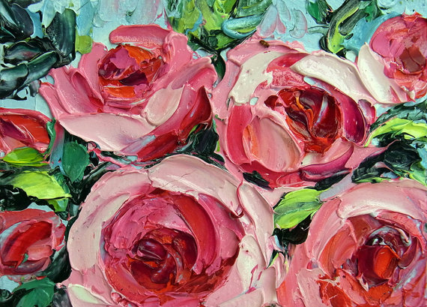
UAL Awarding Body
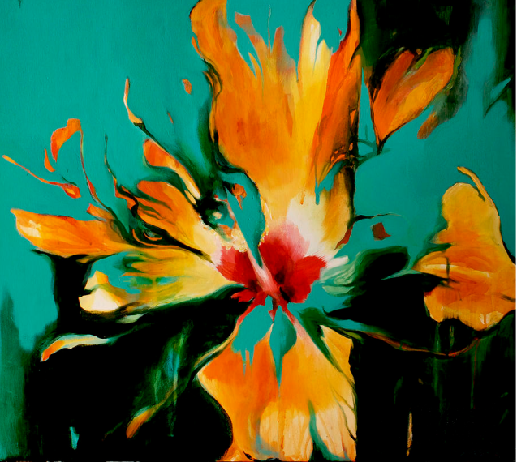

Course Title | Level 1 Diploma in Art, Design & Media
Assignment Title | Summer Assignment: Nature Close Up
Staff | Allyson Beckford
Units Covered | Unit 1: Introduction to materials, processes  & skills in art and design media
Date Set: June, 2026 | Due Date:  You MUST bring this completed assignment into college when you come for your first studio lesson; this date will be sent to you during the summer.
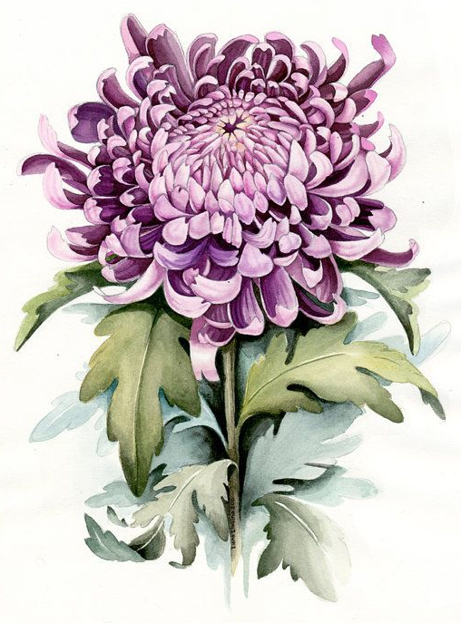

Introduction
The purpose of this summer project is for you to begin to look at the world around you and record what you see using a range of different media and digital photography. Avoid going back to the drawing and painting techniques that you were comfortable with at school, instead, look to explore how others have tackled the theme of this project and aim to have a go at using their techniques. You will need to vary your choice of media as you progress with each drawing you produce.
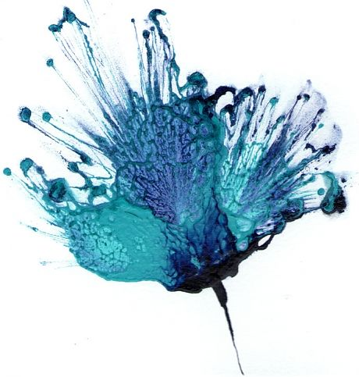
Part 1
- Drawings: I need you to begin by producing some drawings and paintings of objects from nature, but observed close up, selecting various colours and shapes that you find interesting to you. You will need to select a variety of interesting natural forms to work from. Don’t draw from photographs; you must have your objects in front of you as you draw.

- Think about how you draw. Ask yourself what are the most interesting or unusual angles you can use? Don’t draw in the middle of a page and leave the remaining space blank. Aim to draw large to fill the space available and make everything look as interesting as you can.

- If you are stuck and don’t know what to draw perhaps get on-line and look at some examples of other illustrators and artists’ work to inspire you. Many illustrators use plants, flowers, insects and animals within their work so you should be able to find someone whose work could then inspire your own drawings.

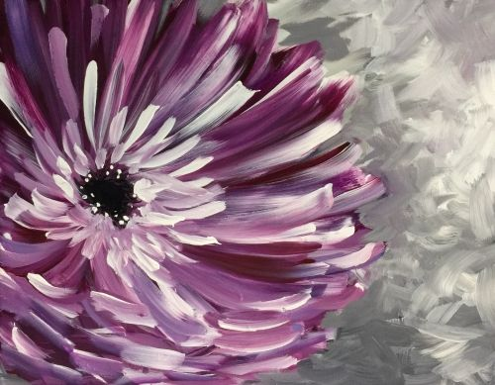
As you develop your drawings, aim to change the media you use with each one. Examples could be biro, a rich coffee wash, charcoal rubbed over a page and then draw into this with a rubber, liquid ink, a range of graphite pencils, marker pens…. the options are endless. Just be imaginative and varied in your approach.

Target: Aim to develop a MINIMUM OF 6 different studies, changing your subject and choice of media in each one of your drawings.

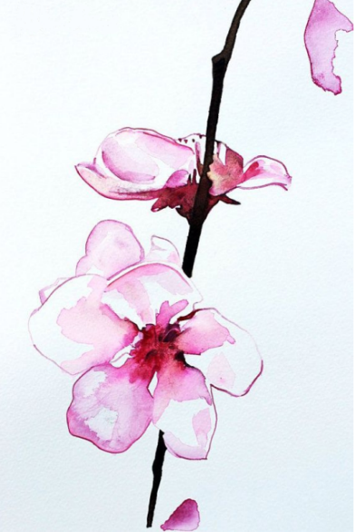
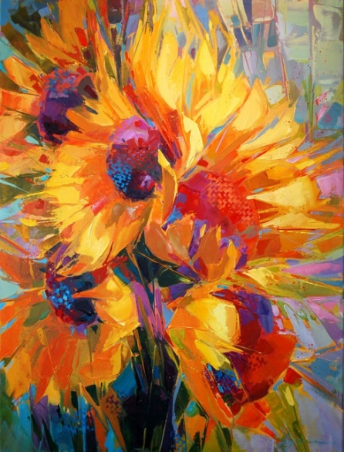
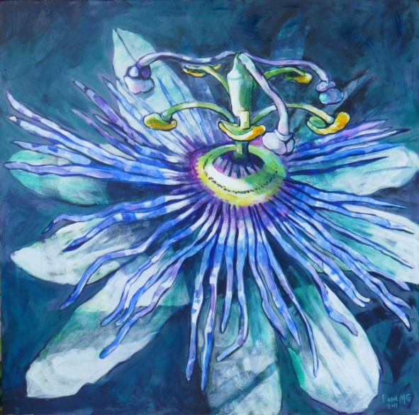
Part 2

Photography: For this section of the project, you will need to have access to a digital camera or a camera phone of your choice. Before you begin, it’s worth exploring your camera’s built-in features, such as the panorama mode, different lighting settings, and the macro feature for sharp, close-up shots. Aim to experiment with these options as you develop your photos. It will also be worth trying out free photo manipulation apps such as Snapseed or Adobe Express to edit your images.
As you go looking for examples of natural forms such as pets, plants, and flowers, aim for interesting arrangements where they are captured within their natural environment, such as in fields, formal gardens, natural meadows, a glasshouse, etc. When off on location, be sure to take someone with you to assist you in your work. If you are heading off on holiday or visiting a new location, this will be a great opportunity to photograph new plants and flowers.
You can work on any size of paper you wish up to A3 and any paper type that you can find; in fact, the more varied the better. You will eventually be mounting your photos into your first A3 sketchbook.

Target: Aim to gather and print out a MINIMUM OF 10 different close-up photographs, targeting your strongest images. This work will form part of your first project assessment so please take your time and ensure that you produce this work to the best of your ability.

How to bring your photos in September:
- Option A: Print them at home or locally over the summer (standard colour prints on plain paper are fine).
- Option B: If you don't have a printer, save your 10 best photos into a dedicated folder on your phone or digital drive. You will be able to print them out during your first week at college.

If you have any questions regarding this work or have any questions about your course, please do not hesitate to email me via
allyson.beckford@ieg.ac.uk
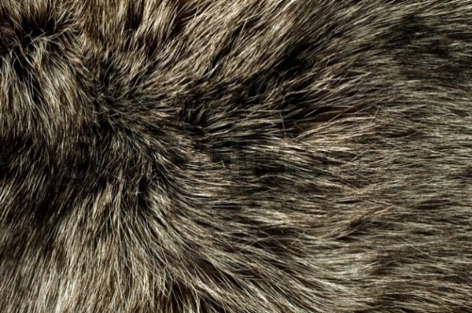
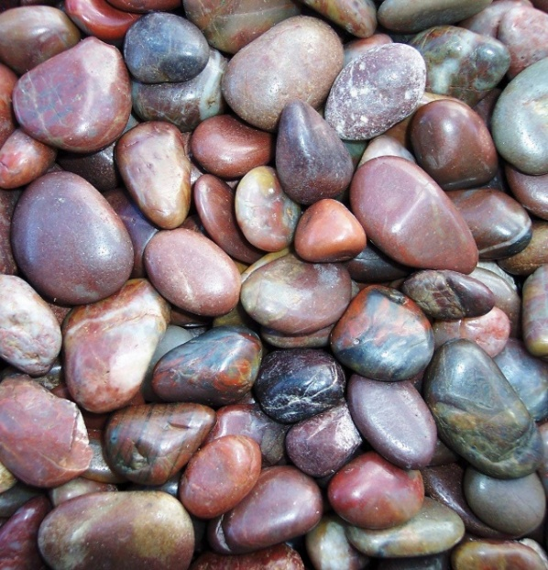
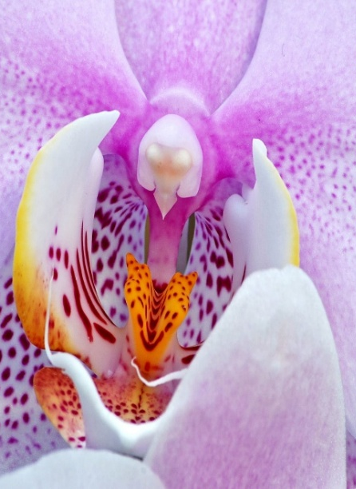

Equipment List
Level 1 Art & Design

In preparation for your start on the Level 1 Art course, you will need to be gathering the following equipment to ensure you are ready to go in September.

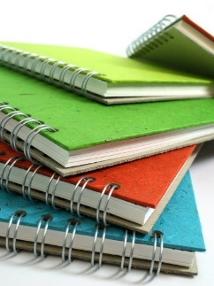
Sketchbook
You will need an A3 sketchbook for your main coursework. Avoid buying a cheap sketchbook as the paper used is of such poor quality. Ideally, choose from the ‘Pink Pig’ range.

Glue Sticks
You will be using a lot of glue sticks over the year, so if you have the opportunity, aim to buy in bulk. We have tried numerous brands, but it’s ‘Pritt’ that always gets the job done.

Graphite Pencils
You will need to source a set of 12 graphite pencils, as the broad range of H to 9B pencils will be crucial in developing your drawing skills over the year.

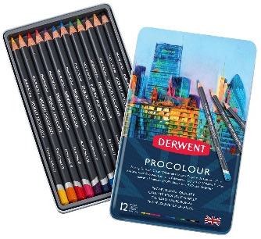
Colour Pencils
As with the sketchbook, it is a case of selecting a good quality brand. Derwent have a good range, from studio pencils to water-soluble pencils, all have proved very reliable.

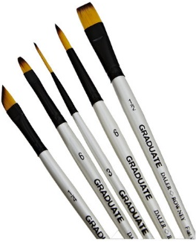
Brushes
There are two varieties, the soft artist brush and the firmer bristled brushes. It’s the soft ones you will need to have. These can be bought as a set from outlets like ‘The Works’ or selected individually from ‘Hobby Craft’. If you are buying individual brushes, target the cheaper but reliable white graduate set of brushes.
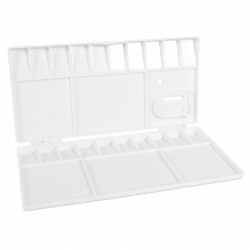
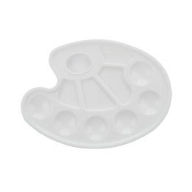
Paint Palettes
You will need a good paint palette. There are lots of choices available but make sure to choose a large plastic palette. Look for one that offers deep wells to hold your paint and plenty of flat space for mixing colours. Avoid tiny palettes, as they won't give you enough room to experiment with colour blends.

A3 Plastic Folder
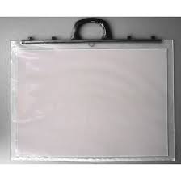
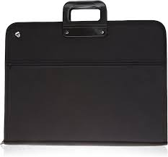
You will need this for carrying your sketchbook and storing your equipment. There are several choices on the market. It is best to select one which is strong and will last for the year.

General Equipment
You will probably have a lot of this left over from school.
Can you ensure you have the following items ready to go:
Metal Ruler, Scissors, Rubber, Writing pen
and a decent sized bag to store all the above equipment

