
Summer Workbook
2026

Approaches to psychology

Research Methods

Social Influences

Memory

Mental health

Attachment

to year 1 Psychology

In the first year we will be learning the following topics…



Research Methods Approaches to Psychology

Mental Health Memory

Attachment Social Influences

This workbook can be downloaded and completed electronically or printed out and written by hand.

You should be able to type in it over the images which are included. If you want to alter your own personal version which you download to make it easier for you or give you more space - that’s fine. You can alter images, add your own images or delete any which are in your way. The important thing is that you look at the ‘key terms’ and start to explore what they mean and that you start to think about the questions which are being asked. These are all things which are part of year one of A-level psychology. Spending some time looking at this in summer, will prepare you for September and we will revisit this book once term starts…

Research Methods

Research in psychology is made up of experiments, observations, interviews, questionnaires and case studies amongst other things.

What is the purpose of researching how people behave and how people think?

This summer become more observant, look at the behaviour of people around you, in real life, online, in films and TV.

Note down here behaviour and thinking habits which are interesting to you…

Approaches

At the beginning of the first year of the A-level we will look at the first four approaches to psychology, we will add two more to this later. The first ones are:

- Behaviourism
- Social Learning Theory (SLT)
- Cognitive
- Biological (including evolutionary)

…we will then add two more into this later …

5. Psychodynamic
6. Humanistic

This will give us six approaches to psychology… six different ways to look at how people (and sometimes animals) think and behave.

Reflection – what do you think causes people to think and behave the way they do? Is it genetic or hormonal, is it because of how they think, how they have been treated by others, what they have learnt throughout their lives…? Is there something else which could explain it better, or do you think it could be a combination of different factors?

Write your initial thoughts below…
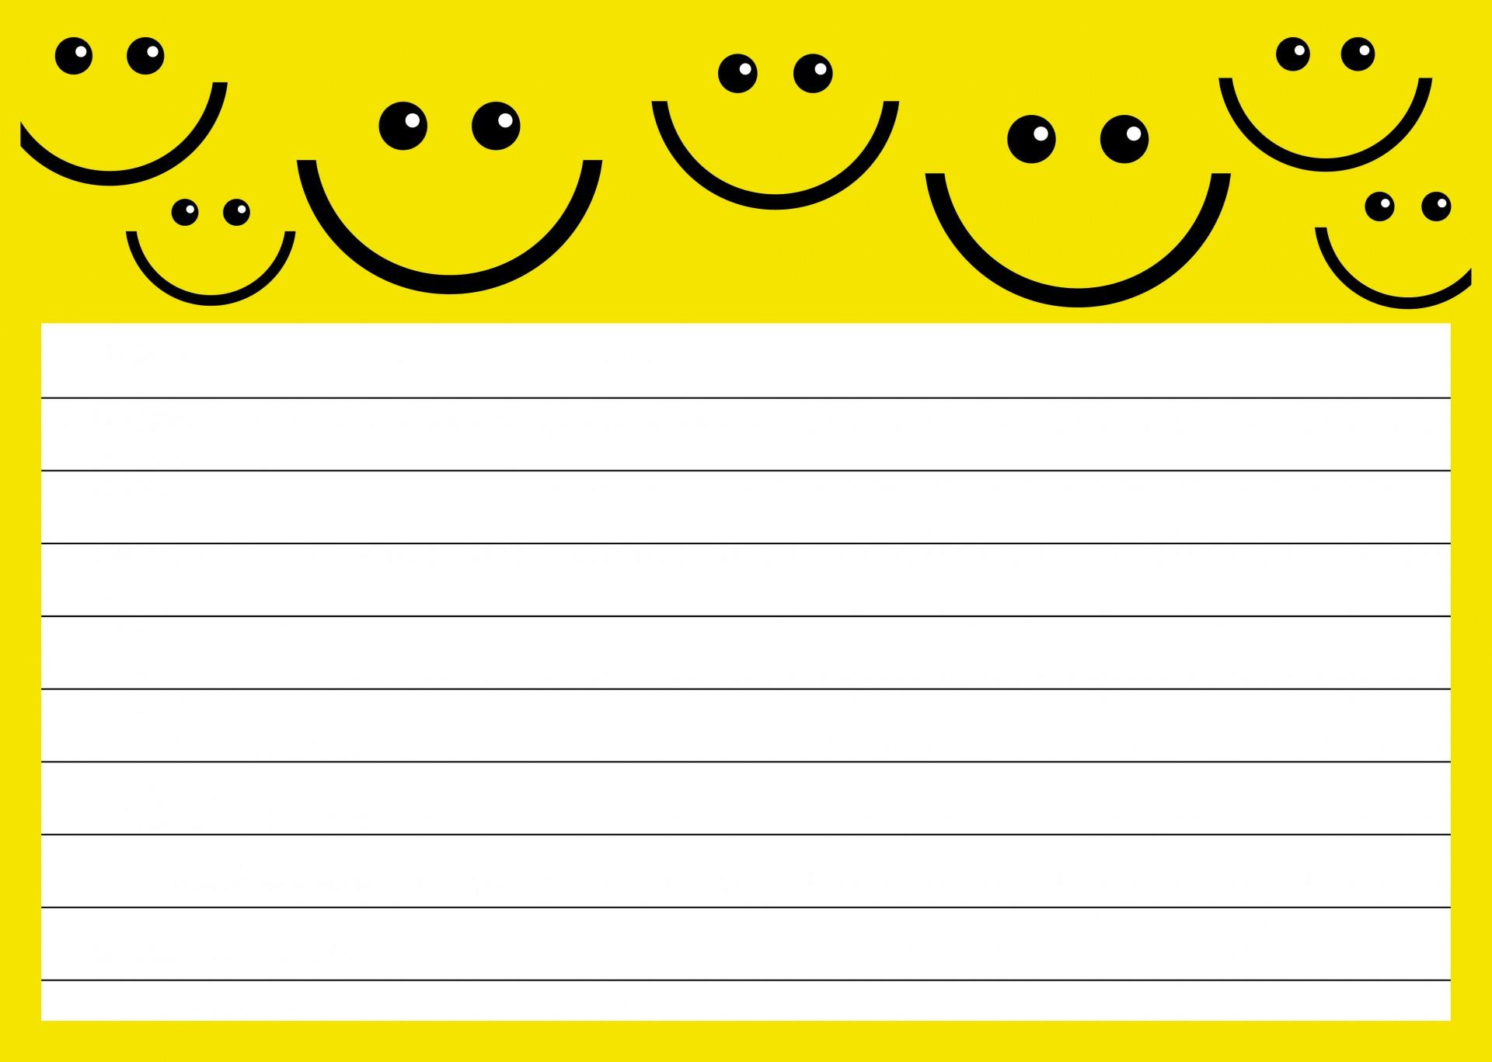

Introduction to the Behaviourist Approach

The key names for this approach are Ivan Pavlov, John Watson and B. F. Skinner. Look them up and see what you can find out about them.

Record this here…

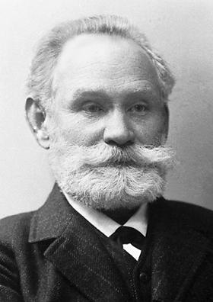

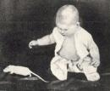
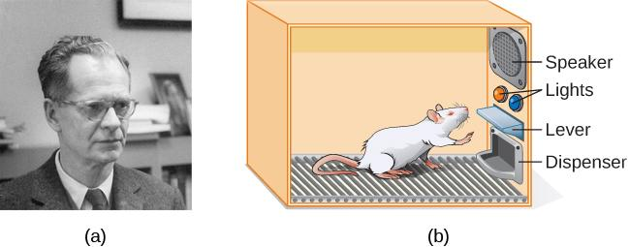

Social Learning Theory
(SLT) Approach

Who is your role model?
Who do you look up to?

Are you aware of why this is?

How much do you think you or other people are influences by TV, films or media?

Look up Albert Bandura – who was he?


What was the ‘Bobo Doll’?

Cognitive Approach

The cognitive approach considers the human mind to be like a computer, it is the ‘information processing’ model.

What do you think?

How is the human mind like a computer and how is it different?

This approach also talks about ‘Schema’. Look up a definition of this word…

How do you think having ‘schema’ can help people learn and remember?

Biological Approach


What do you think of the cartoon above? Could this be a defence for someone who commits a crime?


Memory

Create a mind map of your memories or the general types of things people remember… you can draw pictures or colour code different types of memories, if you want to go into more detail.

What is your earliest memory and how old were you?

What do you think makes it easier to remember something?

Why do you think people forget?
Mental Health

How would you define ‘abnormality’?

In psychology we look at four different definitions of abnormality:

- Statistically infrequency
- Deviation from social norms
- Failure to function adequately
- Ideal Mental Health

Look up at least one of these definitions and explain it below. What does it mean? Do you think it is a good explanation for abnormal behaviour and/or thinking?

Social Influences
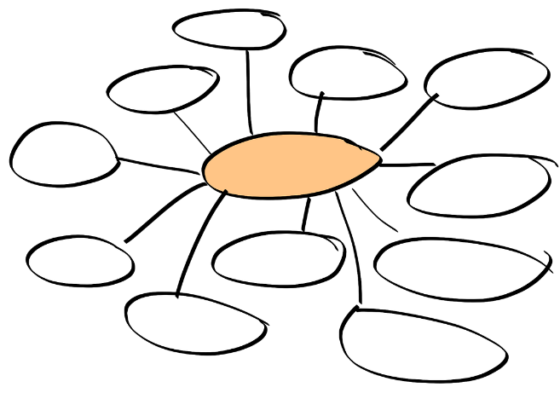
Think about what influences your behaviour and
the behaviour of other people around you.

Create a mind map, you can either enlarge the
one on the right or create your own.

Attachment

What is attachment? Look up a definition?

What or who are you attached to?

