Summer Reading

Your task for this summer is to read one non-fiction text. This could be a biography or autobiography, a published diary, a piece of travelogue, a behind-the-scenes account of a film or TV show, or a collection of journalism.

You should prepare a short presentation about your chosen book to give to a small group at the start of next term. This could be in the form of a powerpoint or Google Slides presentation or prompts on notecards.

You should think about at least five of the following topics:
- The subject matter–what makes this topic interesting and worth writing a whole book about?
- The author–what is their relationship to the subject they are writing about?
- The way the book was organised–why did the author do this and did you find it effective?
- The style of the book–was it very personal and informal or more formal and distanced?
- Who was the target audience? Depending on the type of book, you could consider the age, educational background or location of the intended readers?
- How was it originally published and promoted–is it a collection of online texts, linked to a TV show/other cultural event, a bestseller heavily promoted at the front of the shop, etc?
- What genre is this book? Does it fit your expectations of that genre?
- What did reviewers think of it? Do you agree?

The next few pages contain a list of suggested reading. Everything on this list is a suitable choice but don’t feel you must choose one of these–if you have another interesting non-fiction text you like the look of, read that!

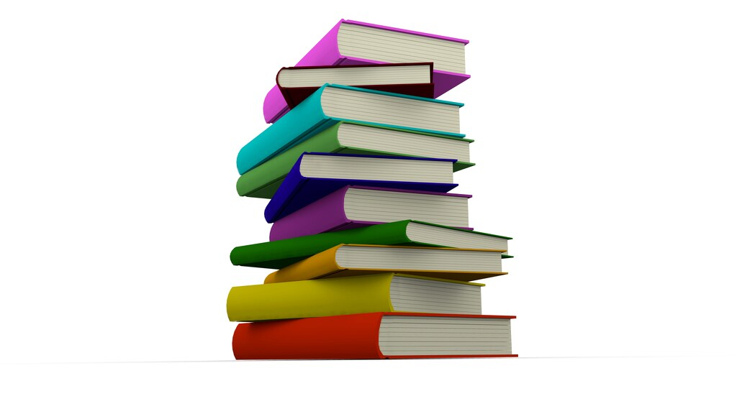
Suggested reading

Autobiography and biography

Title: Becoming
Author: Michelle Obama
Summary: Michelle Obama was the first African-American First Lady of the USA. Becoming is her chance to step out from behind her husband’s shadow and tell her own story--and she does so with warmth and honesty.

Title: All the Young Men
Author: Ruth Coker Burks
Summary: In 1986, twenty-six year old Ruth Coker Burks is visiting a friend in hospital when she becomes aware of a room nurses are unwilling to enter. She ventures inside and finds a young man dying of AIDS. She sits with him as he dies and later arranges his burial. As word goes round that she is willing to help the victims of this terrible illness, she is drawn more and more into caring for those society has rejected.

Title: Bad Blood
Author: Lorna Sage
Summary: Lorna Sage tells the story of her unusual childhood in the 1950s, growing up in an eccentric family on the Welsh border and her fight to access higher education after getting pregnant as a teenager.

Title: A Hope More Powerful Than the Sea
Author: Melissa Fleming
Summary: Fleming tells the true story of Doaa, a young Syrian woman who was one of the only survivors of a capsized refugee ship crossing the Mediterranean. Fleming, who is the Chief Spokesperson for the UN High Commission for Refugees, first told Doaa’s story in a TED talk but has expanded it to write about Doaa’s childhood and her family’s flight from Syria. It’s an intensely moving story which tells the story of one individual caught up in the larger refugee crisis.

Title: Testament of Youth
Author: Vera Brittain
Summary: When WW1 broke out, Vera Brittain was an undergraduate at Oxford. She left her studies to become a nurse, helping wounded soldiers both in the UK and on the Western Front.

Title: Unbroken
Author: Laura Hillenbrand
Summary: Louis Zamperini is the town bad-boy, until his brother teaches him to run...and then he becomes the town hero, running in the 1936 Olympics. When war breaks out, the athlete becomes bomber crew in the Pacific. When his plane goes down, Louis and his two fellow survivors are left floating in shark-infested waters for weeks, until they are captured by the Japanese. And that’s when things get really tough… This is an extraordinary true story, which has since been made into a film.

Title: Many Different Kinds of Love
Author: Michael Rosen
Summary: Famous poet Michael Rosen nearly died of Covid in 2020. This is his account of his time in hospital and his tribute to the hardworking doctors and nurses who saved him, illustrated by Chris Riddell. It combines letters written by his family and the nurses who cared for him and his own writing.

Title: I Know Why the Caged Bird Sings
Author: Maya Angelou
Summary: In this first volume of her autobiography, Maya Angelou tells the story of her childhood, growing up with her grandmother in the American South. It’s also the story of cruelty and discrimination she faced--how she lost her voice and found it again.

Diaries

Title: Nella Last’s War
Author: Nella Last
Summary: Nella Last was a middle class housewife in Barrow-in-Furness during World War Two. Her diary is a record of what it was like to live through the war, including the bombing of the local dockyard.

Title: The Last Expedition
Author: Robert Falcon Scott
Summary: On his journey to the South Pole in 1910-1912, Captain Scott kept detailed journeys describing the world of the Arctic and the challenges his team faced. Scott did not survive the journey and his diaries were found with his body several months after his death.

Title: Diary of the Plague Year
Author: Daniel Defoe
Summary: In 1665, the bubonic plague swept through London. Daniel Defoe was a child at the time, but based this fictionalised account on his uncle’s experiences.

Travelogues

Title: Notes From a Small Island
Author: Bill Bryson
Summary: First published in 1995, this is a humorous look at Britain from a long-term American resident. This has become a classic of travel writing.

Title: As I Walked Out One Midsummer Morning
Author: Laurie Lee
Summary: In 1934, young Laurie Lee left his home in the Cotswolds to head first for London, and then for Spain. This is his account of a year wandering through Spain with a blanket and a violin.

Title: True North: Travels in Arctic Europe
Author: Gavin Francis
Summary: The author’s previous book was about his experiences working as a doctor in Antarctica. Now he heads north to explore the Shetland Islands, the Faroes, Iceland, Greenland, Svalbard, and Lapland, and try to understand what it’s like to live on the Arctic Circle. The author’s other books range from fascinating explorations of the human body to quirky travel writing and are all recommended.

Title: Full Tilt: Ireland to India with a Bicycle
Author: Dervla Murphy
Summary: At the age of thirty-one, Dervla Murphy set off to cycle to India by herself, encountering snow, starving wolves, and the astonishment of everyone she meets along the way.

Title: Love and War in the Apennines
Author: Eric Newby
Summary: When Eric Newby escaped from an Italian prisoner-of-war camp in 1943, he hid out in the Italian Po Valley. For three months, he was fed and helped by an informal network of local peasants, including a beautiful girl on a bicycle.

History

Title: Symphony for the City of the Dead
Author: M. T. Anderson
Summary: The shocking story of the 1941 Siege of Leningrad and the desperation of those caught inside is also the story of the composer Dmitri Shostakovich and the symphony he wrote for his suffering city.

Title: The Finest Hours
Author: Michael J Tougias, Casey Sherman
Summary: In the winter of 1952, two oil tankers are caught in a ferocious storm which begins to split them apart. This is the true story of the Coastguard rescue of the men aboard the ships, and the danger faced by the tiny boats that went to the rescue. You may have seen the film!

Title: Hidden Figures
Author: Margot Lee Shetterly
Summary: The story of the African-American female mathematicians who calculated the flight paths for the mission. The space race took place in the Civil Rights era, and Shetterly explores both the injustices these women faced and the fascinating history of how humanity reached the moon.

True Crime

Title: The Psychopath Test
Author: Jon Ronson
Summary: Ronson starts off by investigating what makes someone a psychopath and goes on to explore the extent that psychopathy has influenced society. Fascinating and rather disturbing.

Title: The Five: The Untold Stories of the Women Killed by Jack the Ripper
Author: Hallie Rubenhold
Summary: There are a lot of books about famous Victorian serial killer Jack the Ripper out there. This one takes a completely different focus, by investigating the lives of his victims and what they show us about the lives of poor women in Victorian England.

Title: Black Klansman
Author: Ron Stallworth
Summary: The true story of a black policeman who went undercover in the KKK, sabotaging their racist activities and exposing the truth. Again, you may have seen the film!

Society

Title: Brit(ish): On Race, Identity and Belonging
Author: Afua Hirsch
Summary: Hirsch explores issues of race and identity today, the way the British deny the impact of their imperial past and the history of British racism. Powerful and provocative.

Title: Freakonomics
Author: Steven D. Levitt and Stephen J Dubner
Summary: A fascinating look at causes and correlations and the surprising connections between things. Answering such questions as why do drug dealers live with their mums and what do schoolteachers and sumo wrestlers have in common, this is a fascinating look at the weirder corners of economics and the hidden explanations for modern life.

Title: Everyday Sexism
Author: Laura Bates
Summary: In 2012, Laura Bates started the website everydaysexism.com, where women could anonymously report incidents of everyday harassment and sexism. She was expecting a hundred responses--she got 25,000 in the first year, from women and girls of all ages, all over the world. This book draws on the website and her further experience campaigning against sexism to draw a picture of how sexism and harassment continue to be a problem in the world today.

Title: Breathtaking
Author: Rachel Clarke
Summary: This is a doctor’s account of the first wave of the pandemic, telling an insider story of what it felt like to work with patients dying of Covid-19. Clarke tells not just her own story, but that of her colleagues in intensive care and of the patients themselves.

Science and Nature

Title: Diary of a Young Naturalist
Author: Dara McAnulty
Summary: This memoir explores nature through the perspective of McAnulty, an autustic teenager obsessed with nature, as he struggles to cope with the pressures of school and exams whilst pursuing his passion for nature.
.

Essays and Interviews

Title: We Should All Be Feminists
Author: Chimamanda Ngozi Adichie
Summary: This short read is based on Adichie’s excellent TED talk on the same topic. Here she argues that twenty-first century feminism should be inclusive of all women’s experiences across the globe.

Title: The Good Immigrant
Author: Nikesh Shukla (ed.)
Summary: A collection of essays by people of colour exploring what it means to be an immigrant in the UK today–this tackles prejudice and identity from multiple perspectives.

